1. Deploy Your flask backend and express frontend in amazon single ec2 instance.

Ans:

Step1:

* I have created a project and uploaded it on github. It has two parts are
  + frontend : It has a folder “express-frontend/express-server” and it has a file “[server.js](http://server.js)” file to run this project.
  + Backend: It has a folder “flask-backend” and it has a “[app.py](http://app.py)” file to run this project.
  + Database: I have used mongo db to store data on mongodb atlas.

Step2: Now the project is ready and I have to configure a AWS EC2 instance to run this project. These are the following steps to do all this.

1. Create EC2 using AWS Console lets start.
   1. EC2 service console lets click on launch instance and fill form.

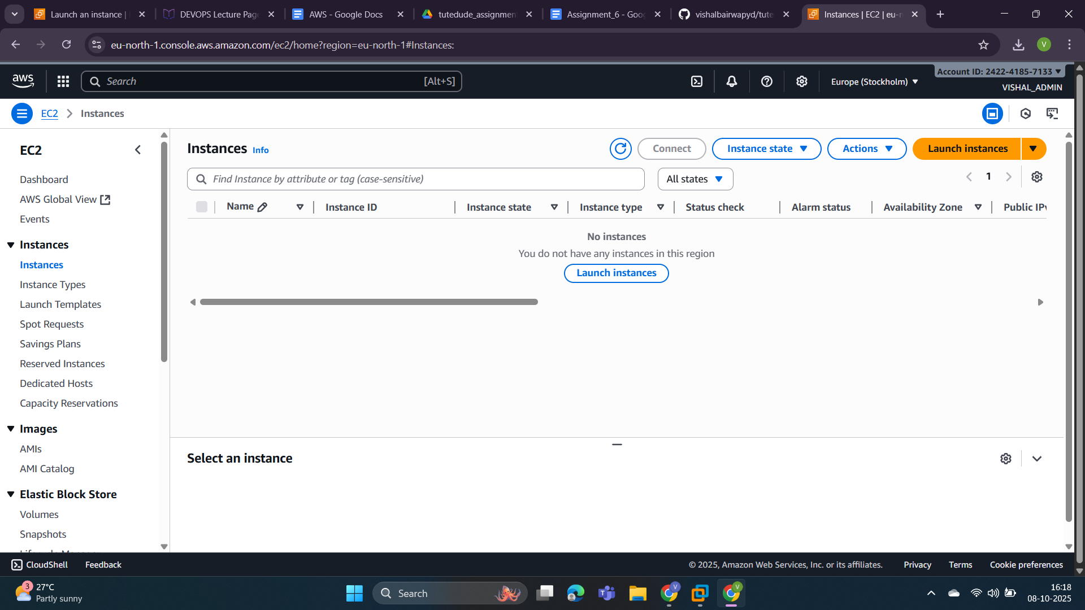

* 1. Created a key-pair to connect this EC2.

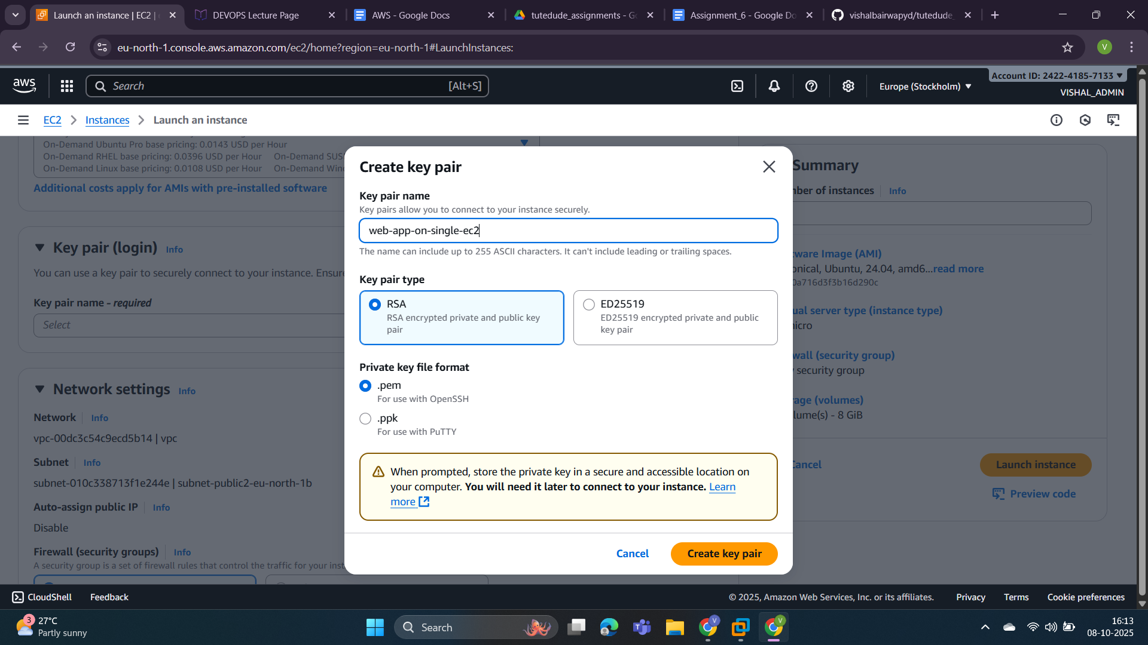

* 1. Now add a security group named “single-ec2-web-app”. In the security group I have to add two ports one is port 3000(for frontend) and another is 5000(for backend) to access running projects on the AWS EC2 project.

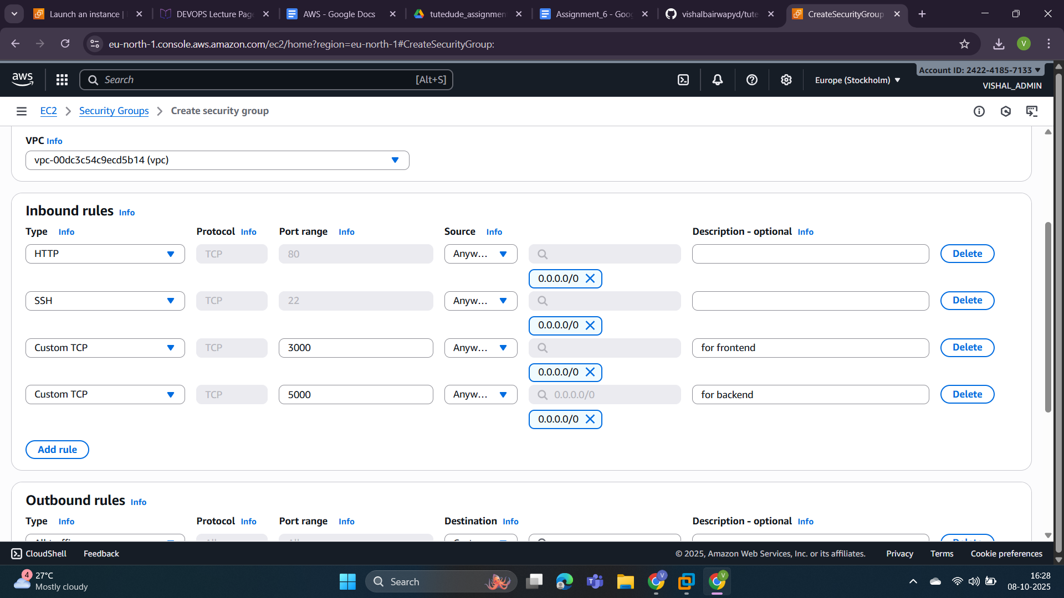

* 1. Now I have completed the form to create an EC2. You can check the summary on the attached screenshot.

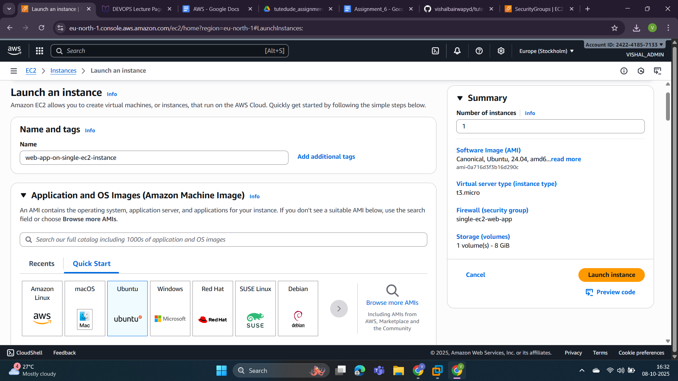

* 1. Now click on “launch instance” and i you can see I have created an instance successfully that status is running right now.

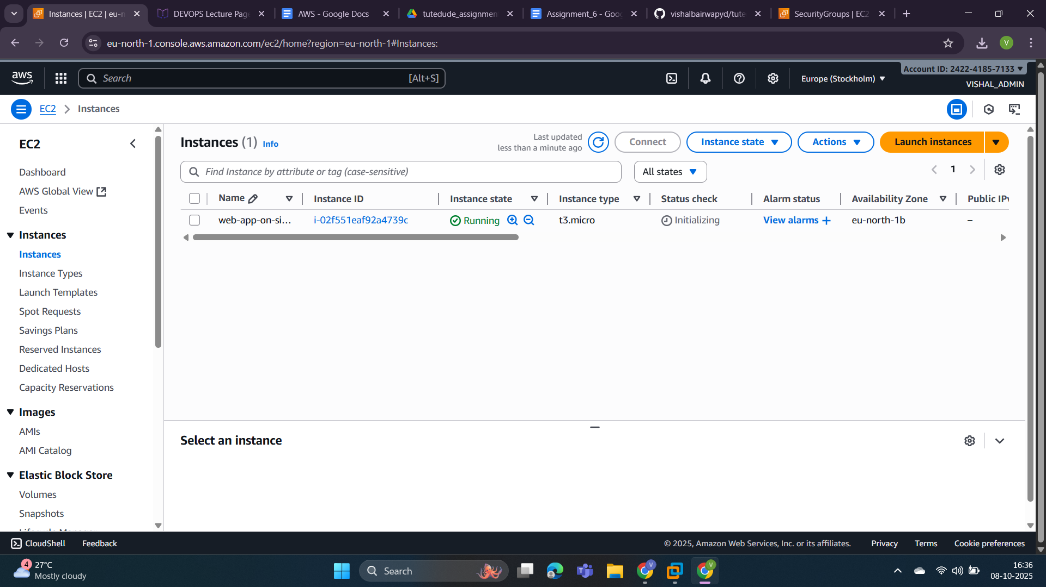

1. Now assign a public ip to the created EC2.
   1. In EC2 service click on “Elastic IP” from “Network and Security category”. Now select an ip from the list and click on the action button and select “associate elastic ip address”.

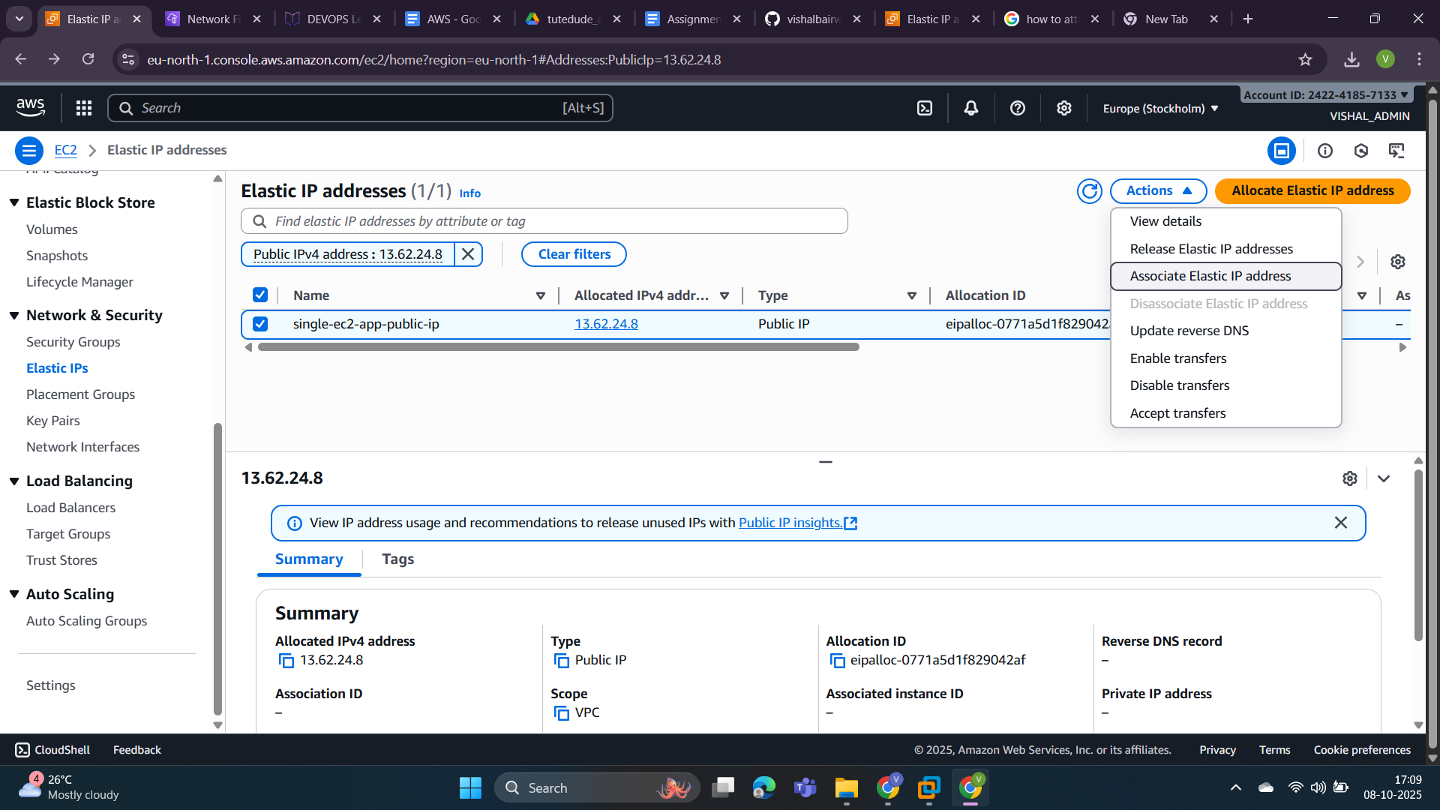

* 1. Now select instance and private ip and click on “associate” button.

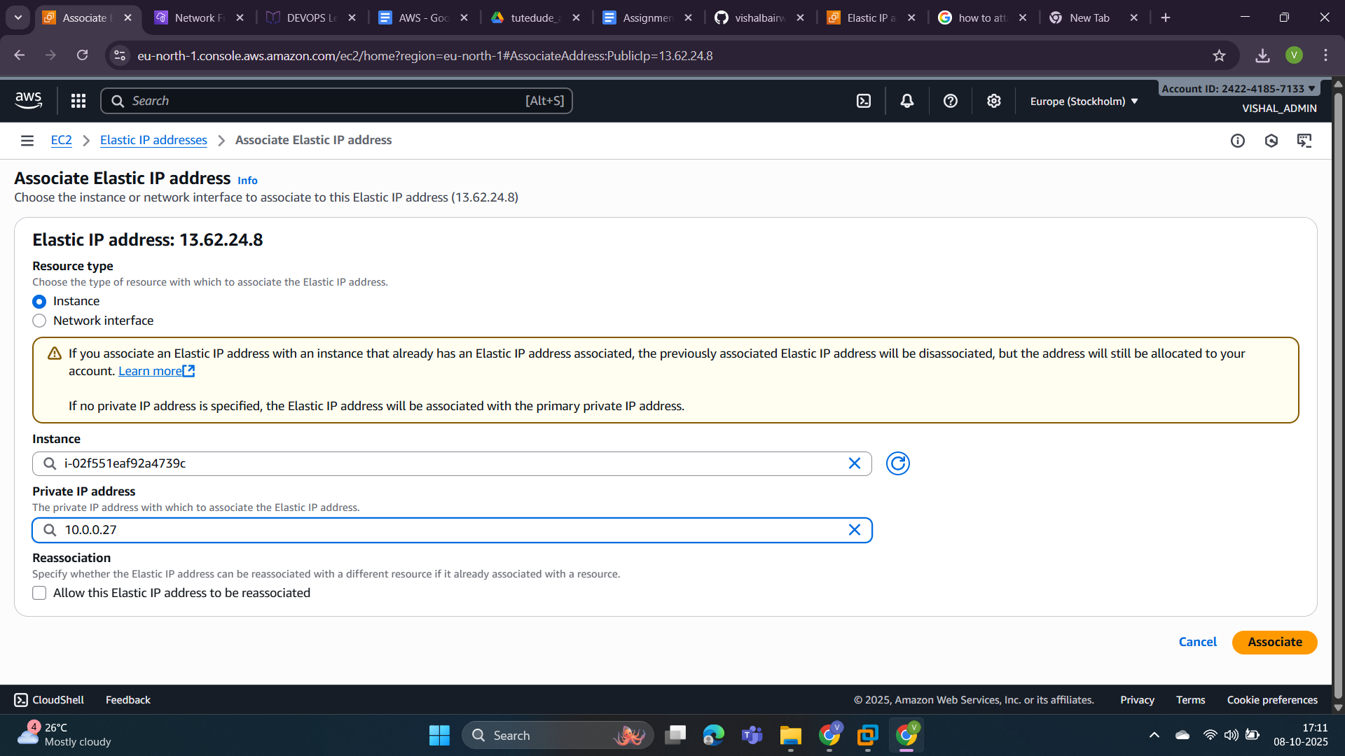

* 1. Elastic IP address associated successfully. Now we can check our instance it may assign public ip to connect local machine to it.

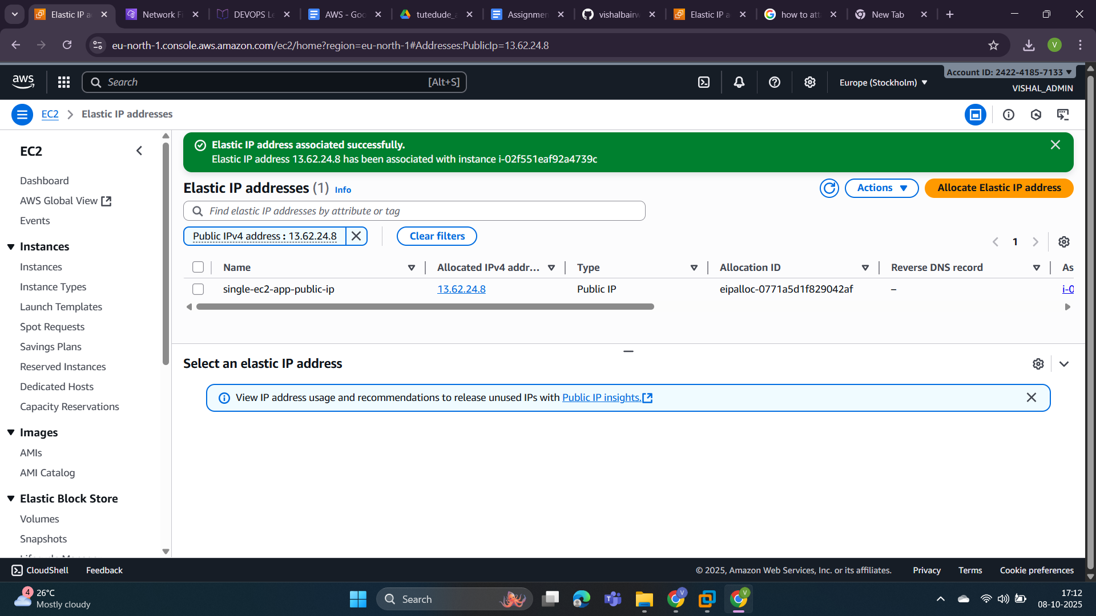

* 1. In the below screenshot you can see we have successfully attached a public IP to create an EC2 instance.

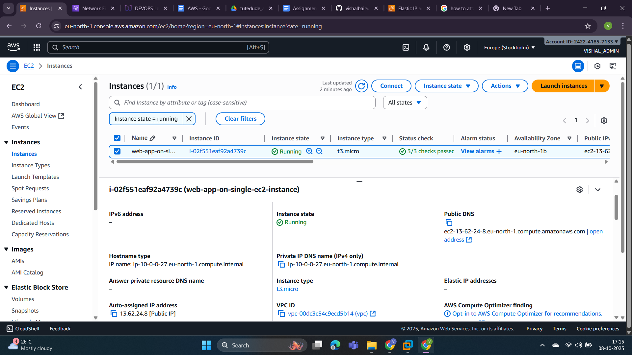

1. Now connect to our created aws EC2 instance with the help of “web-app-on-single-ec2.pem” file.

Command:- ssh -i web-app-on-single-ec2.pem [ubuntu@ec2-13-62-24-8.eu-north-1.compute.amazonaws.com](mailto:ubuntu@ec2-13-62-24-8.eu-north-1.compute.amazonaws.com)

You can see we connected to our EC2 successfully. 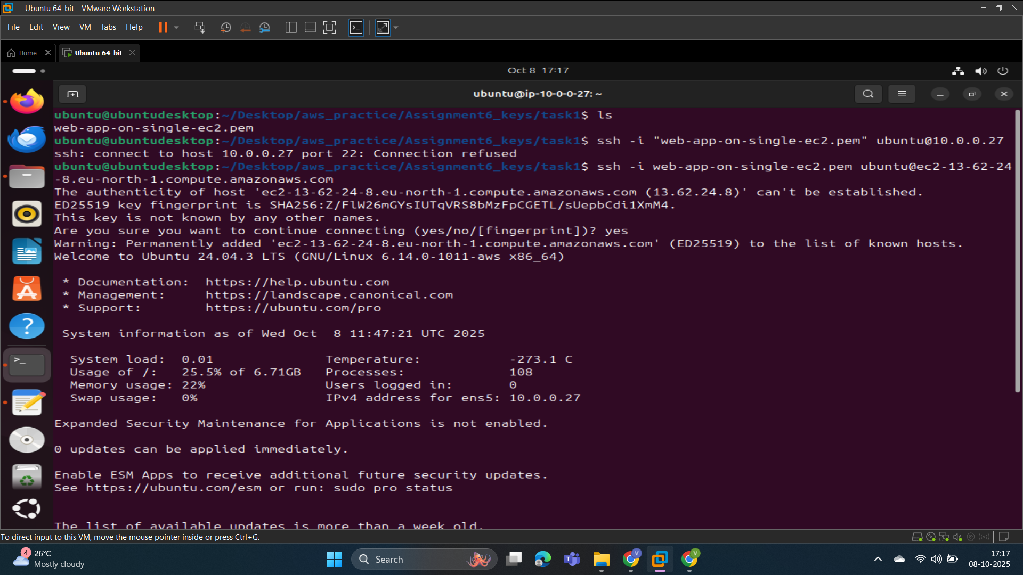

1. Now deploy our web app on this machine.
   1. Project clone successfully.

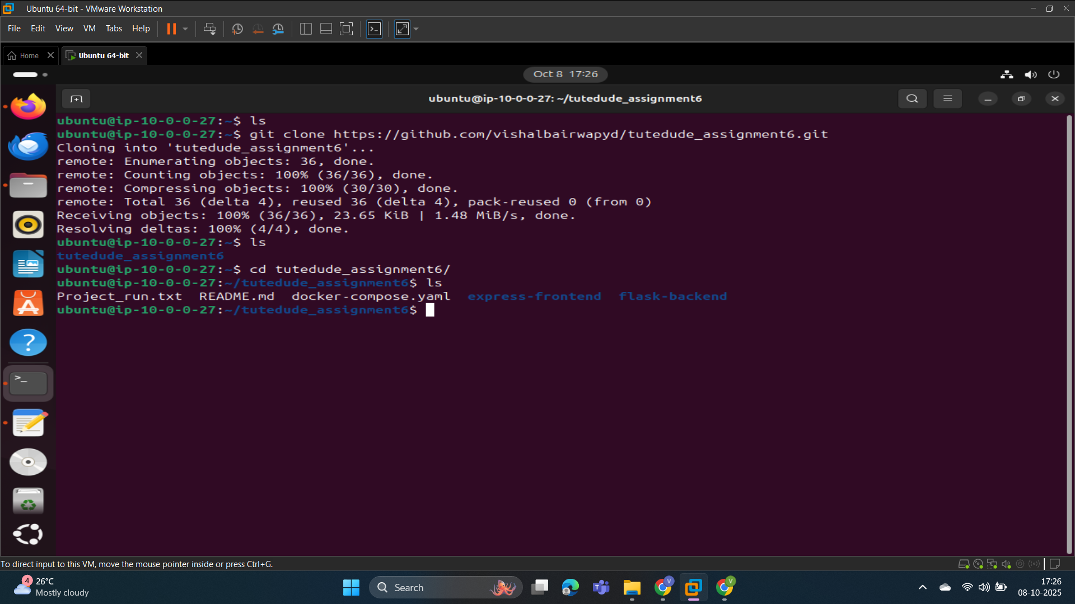

* 1. Now install docker first.

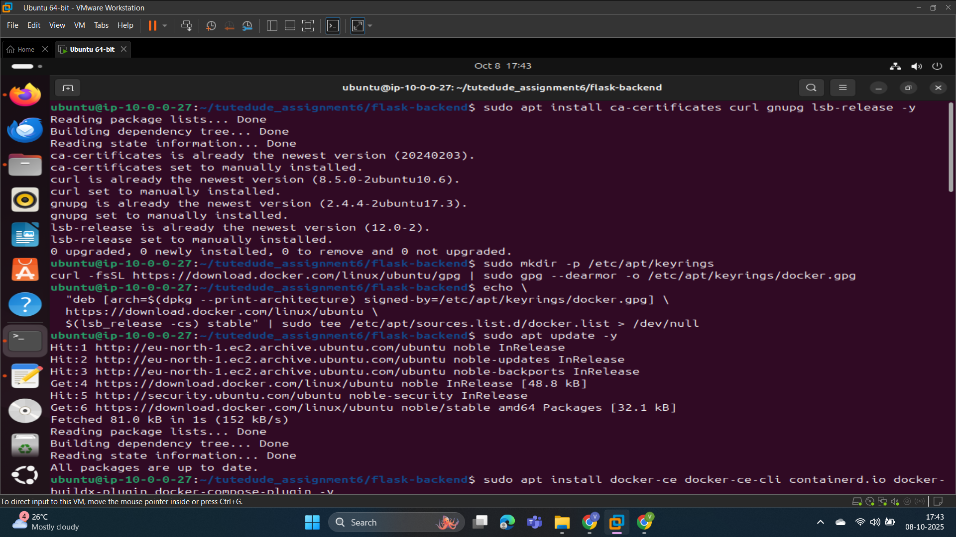

Docker installed successfully.

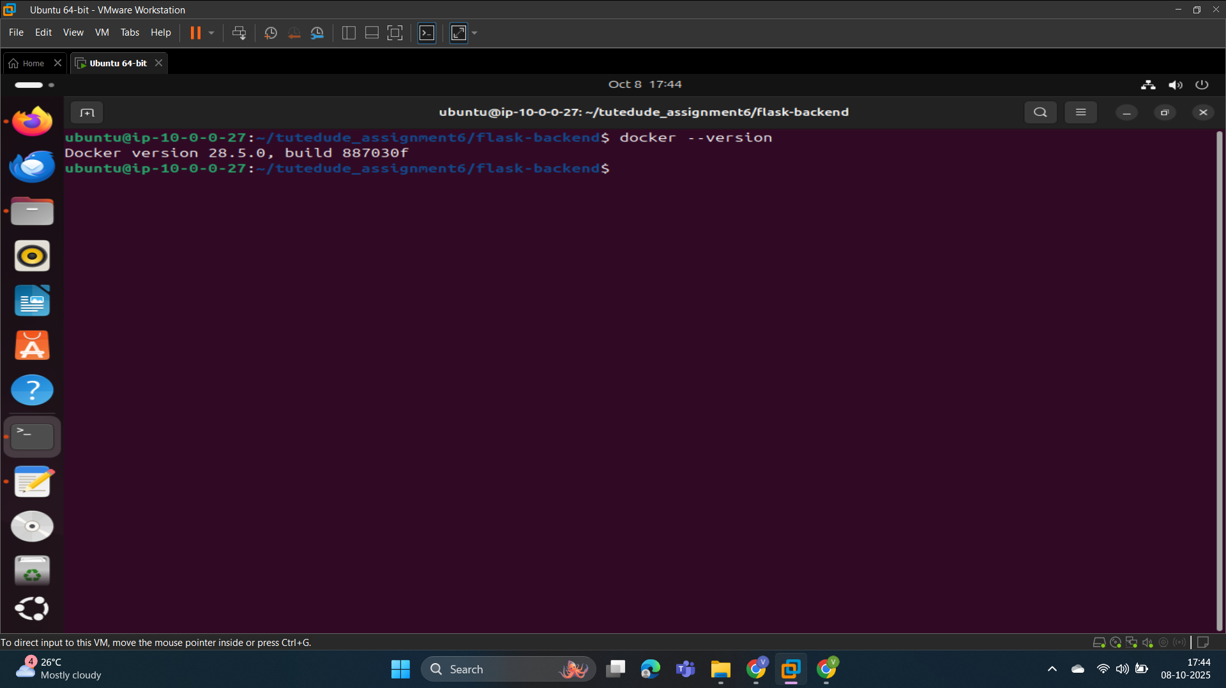

* 1. Now run our project on this machine using docker.

Command: docker compose up --build

Note: but remember you should be in the “tutedude_assignment6/” directory and you have a “docker-compose.yaml” file.

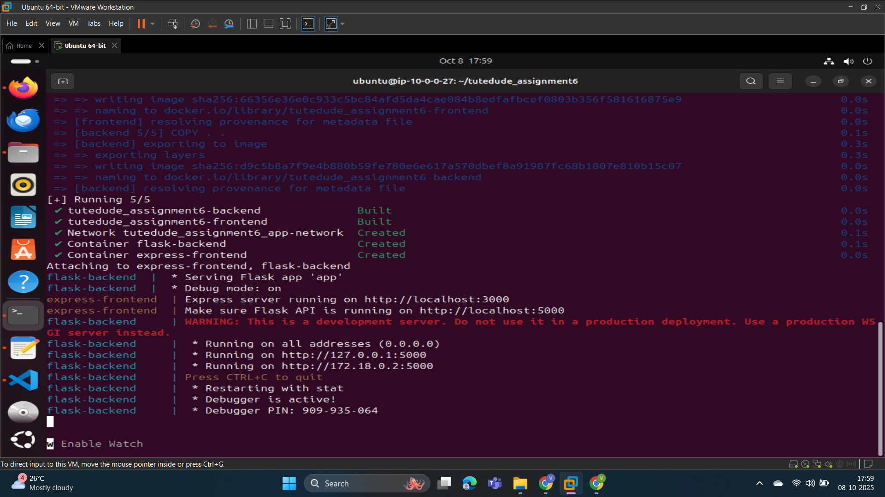

* 1. Now the project runs successfully. Let’s open it in the browser.

This is the base URL of the project:

<http://ec2-13-62-24-8.eu-north-1.compute.amazonaws.com>

* + 1. Backend: To access backend we access port 5000.

url-> <http://ec2-13-62-24-8.eu-north-1.compute.amazonaws.com/api/health>

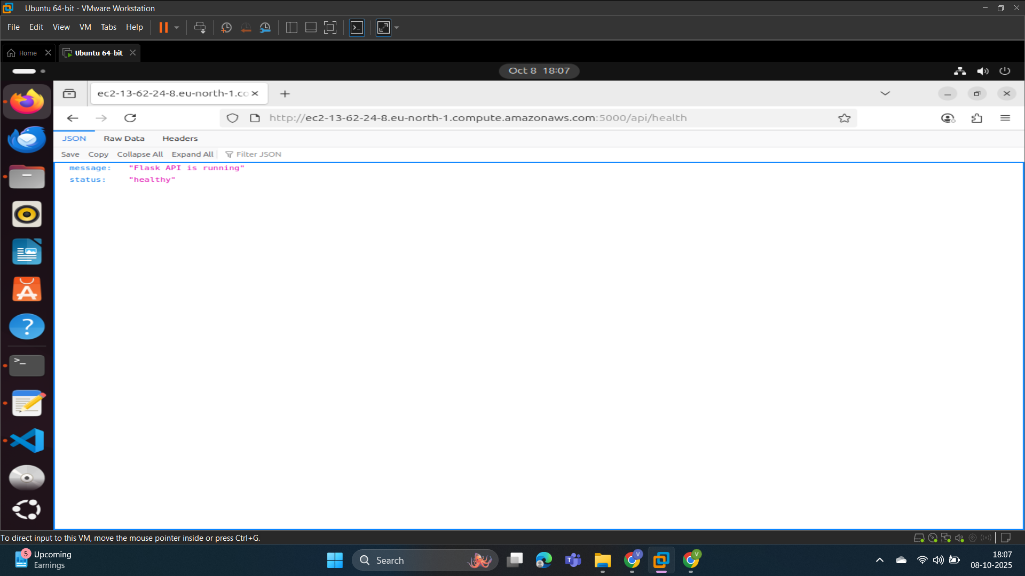

* + 1. Frontend: To access frontend we access port 5000.

url-><http://ec2-13-62-24-8.eu-north-1.compute.amazonaws.com:3000/>

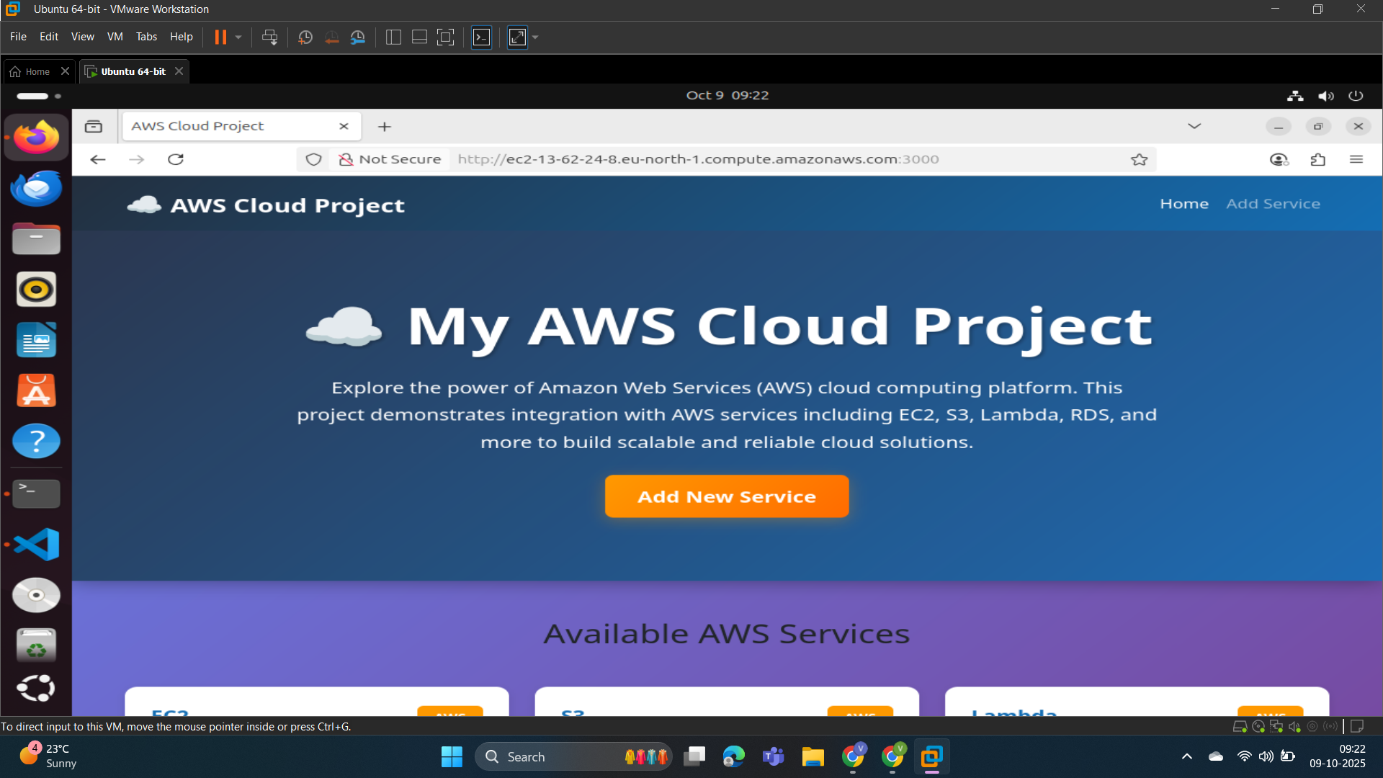

* + 1. Frontend + Backend: Let’s check our frontend is able to connect with the backend and load data.

In the below screenshot you can see this working fine.

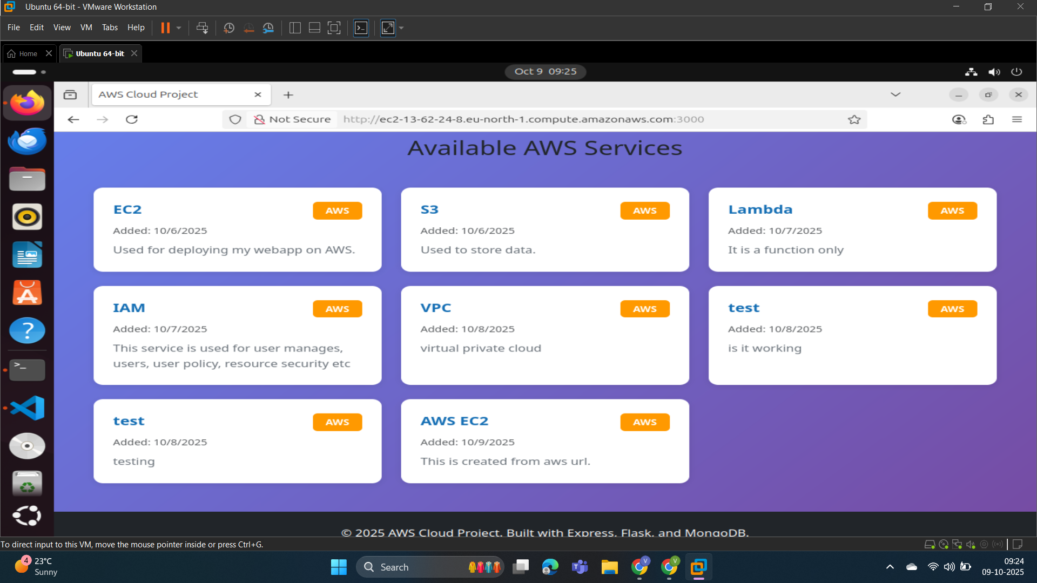

* + 1. We can add service from the frontend by clicking on the “Add Service” button. A form page will appear and we can fill it to add any services.

2. Deploy Your flask backend and express frontend Docker Container using aws ecr, ecs and vpc services

Ans:

Step1: Let’s create an ECR(Elastic Container Registry) repository and push a docker image in it .

1. For backend: ECR repository named “web-app-backend”.

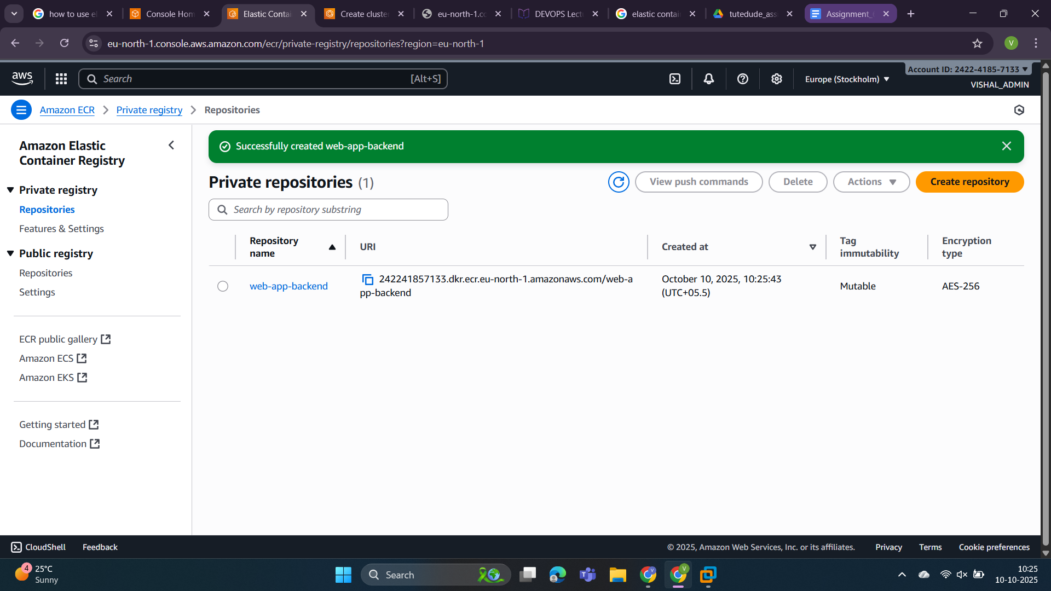

Now push a docker image into it.

These are the instructions needed to push code into the created repository.

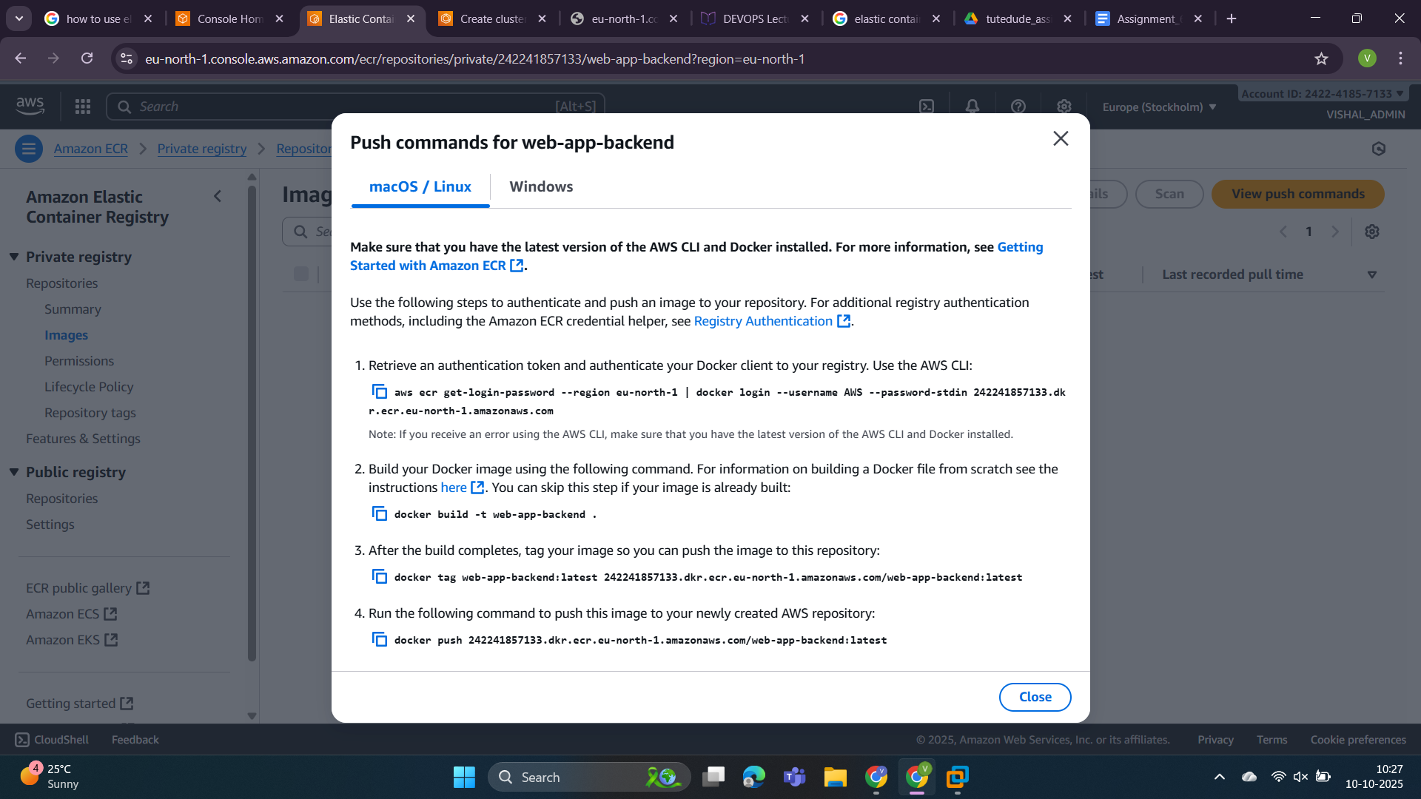

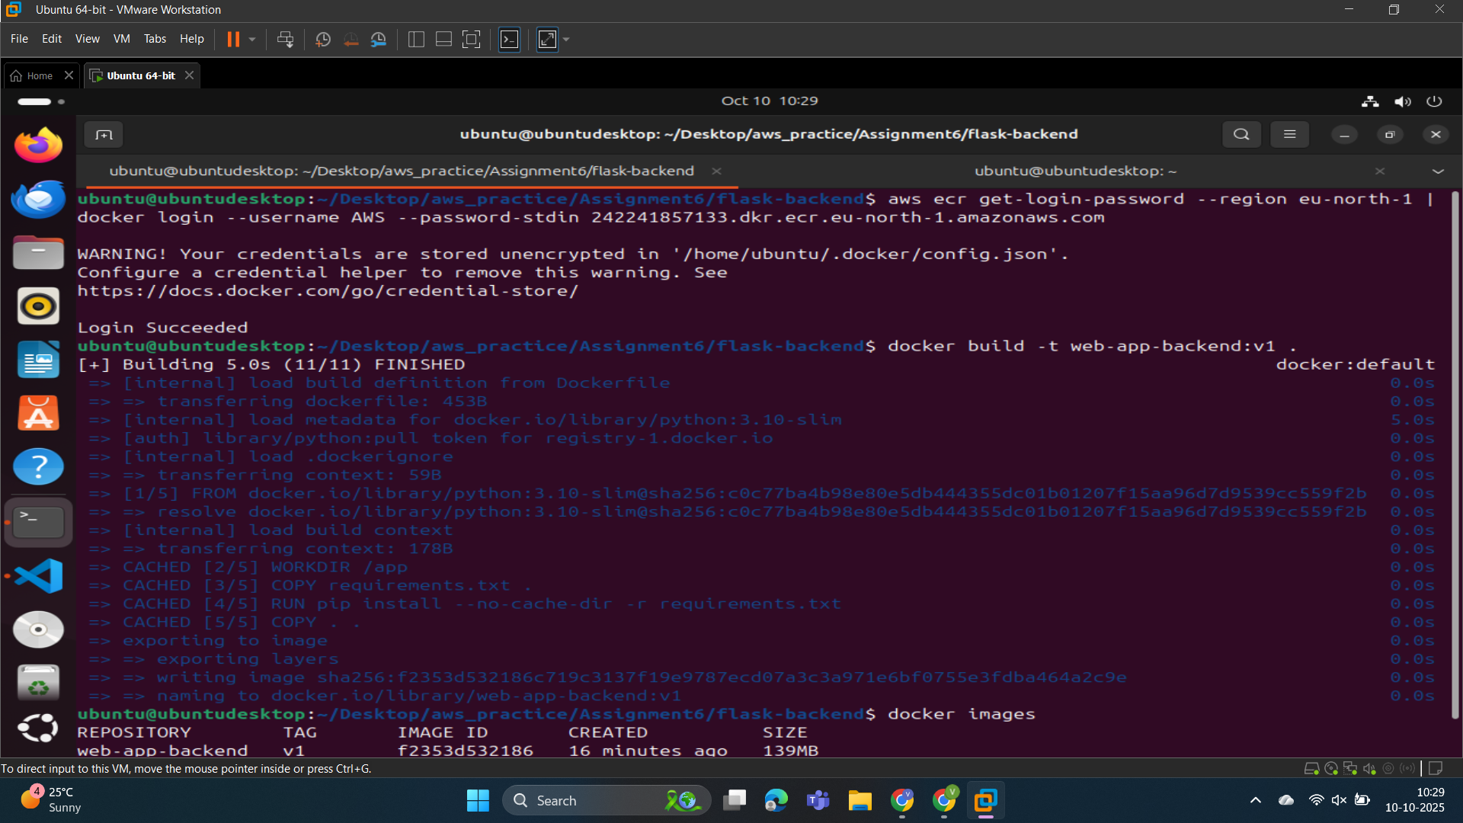

Docker image pushed successfully from local. Let’s check in the created ECR repository.

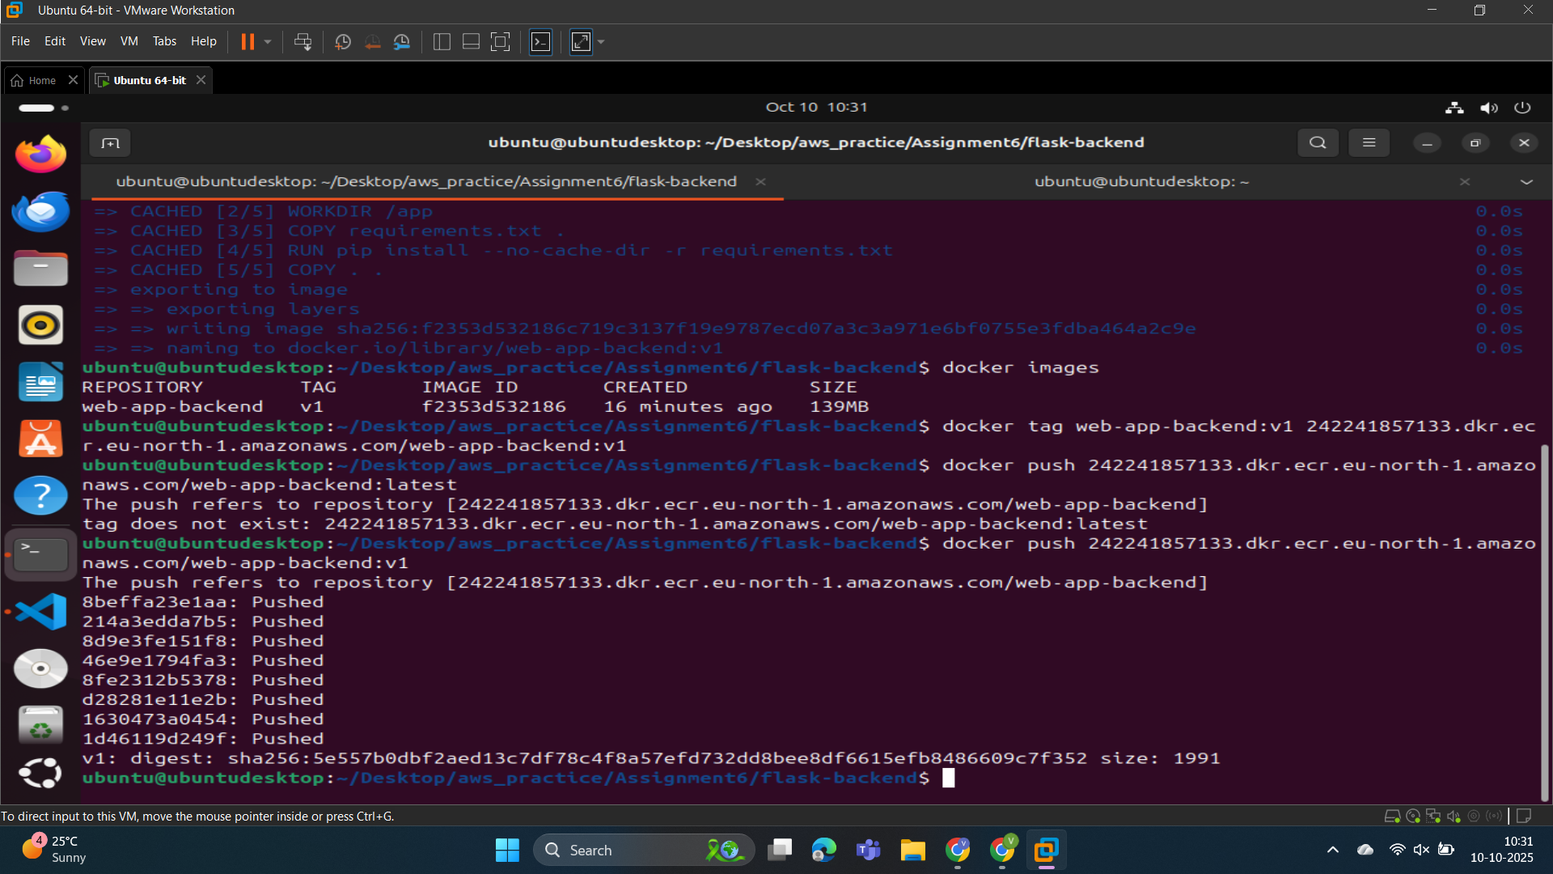

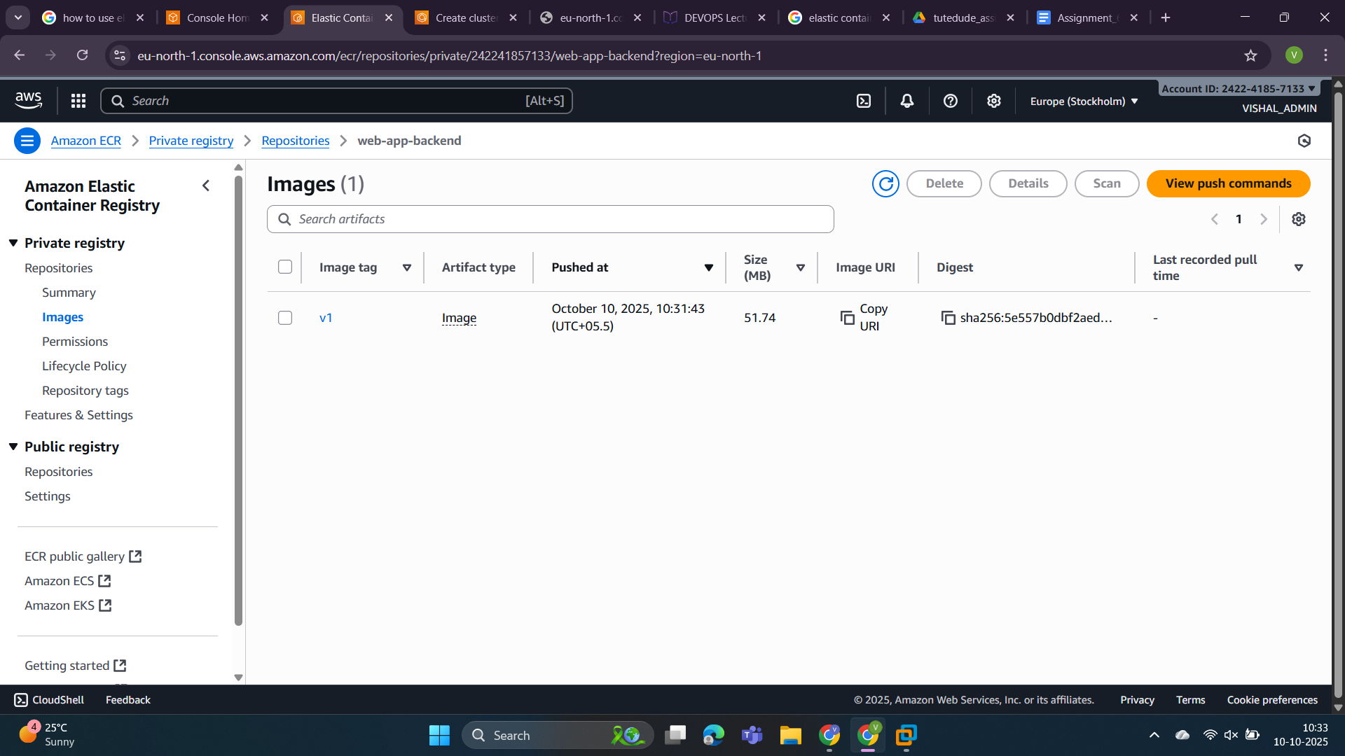

1. For Frontend: ECR repository named “web-app-fronend” and push a docker image into it.

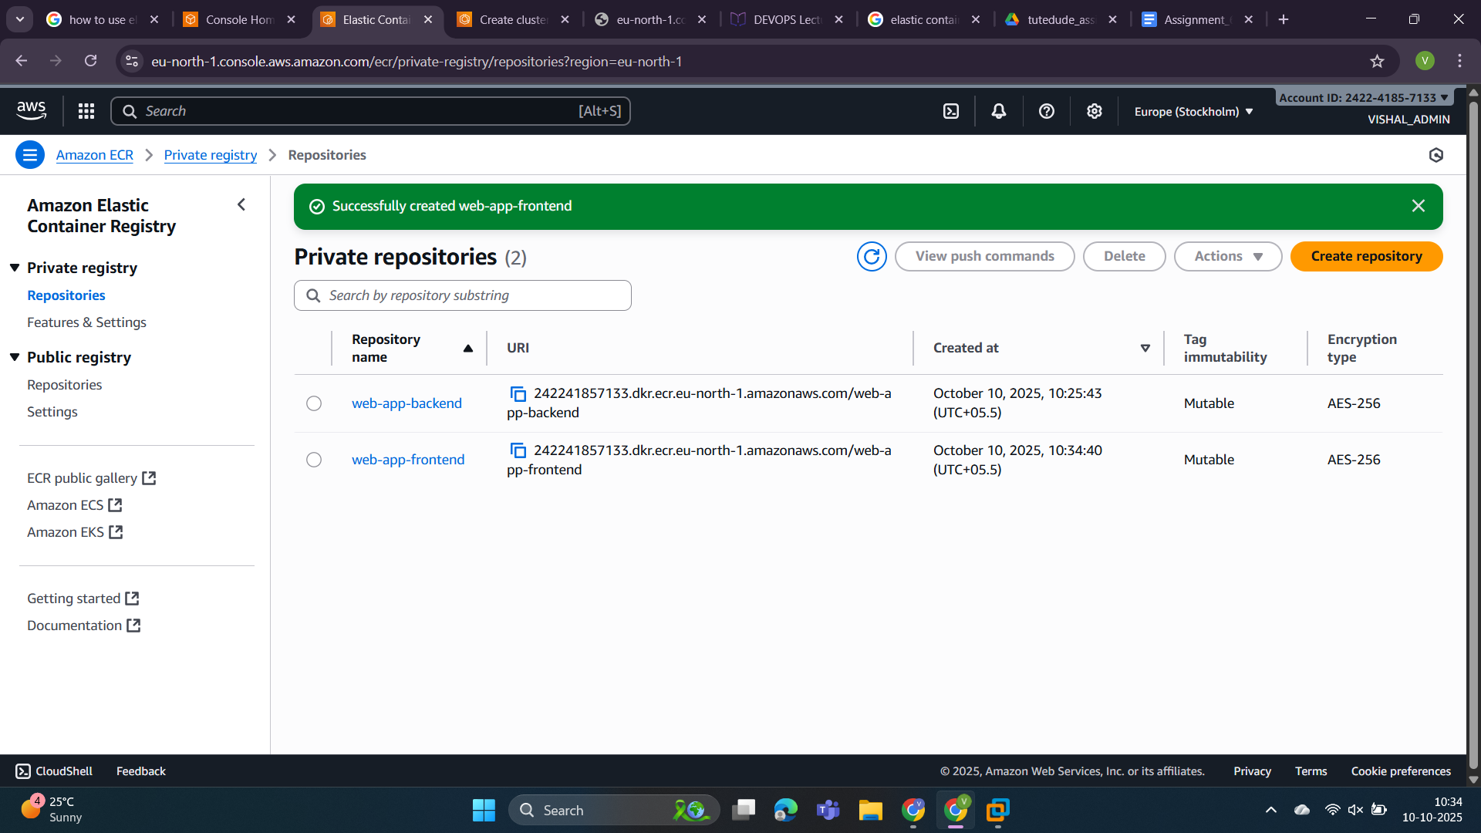

Now push docker image similarly like above.

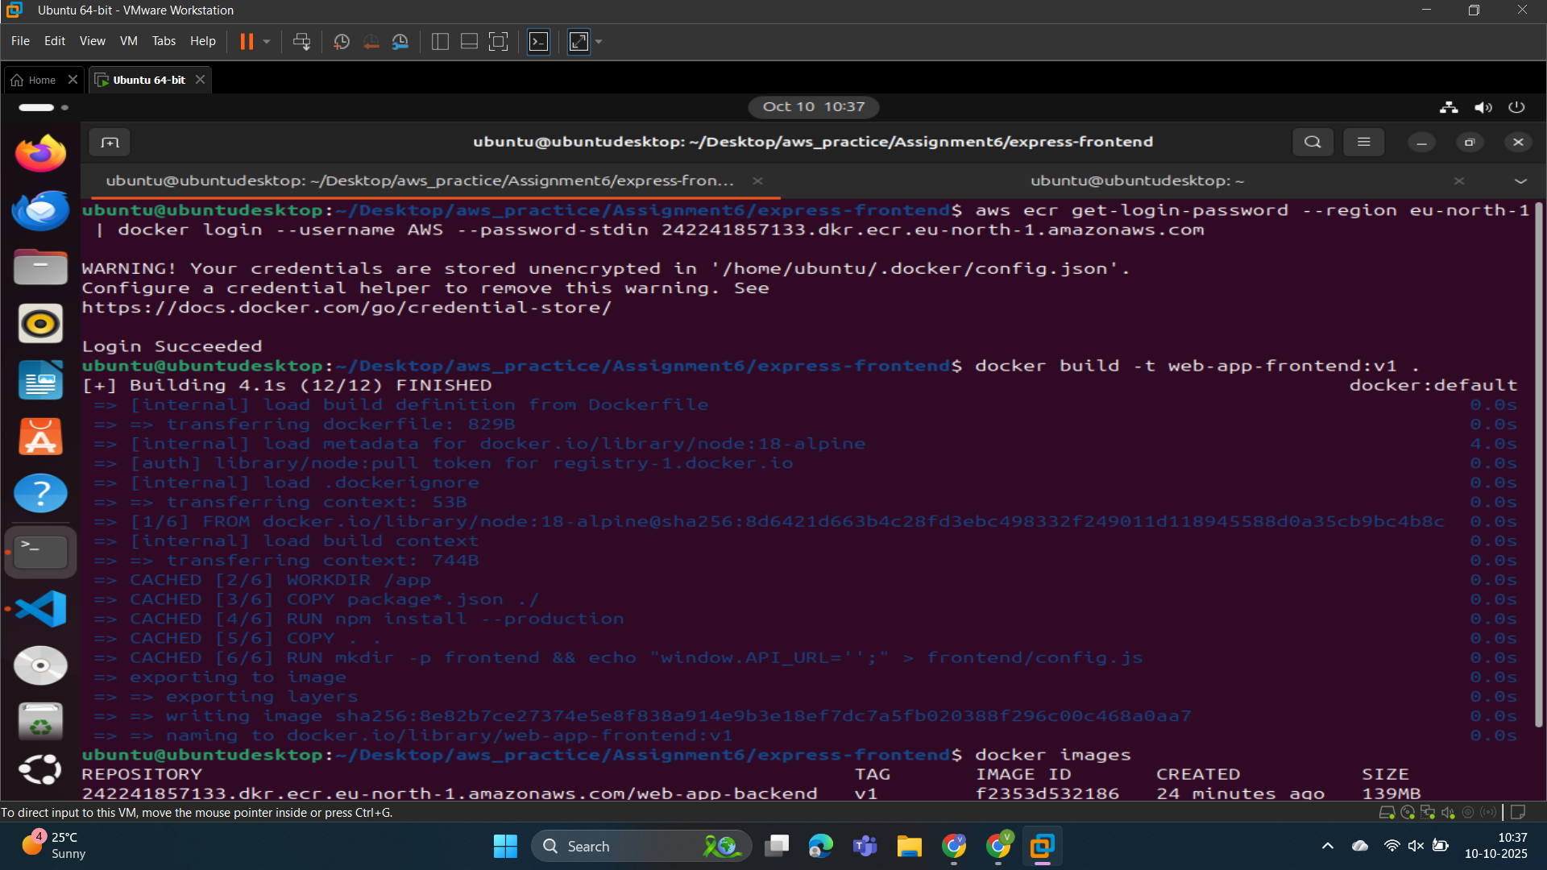

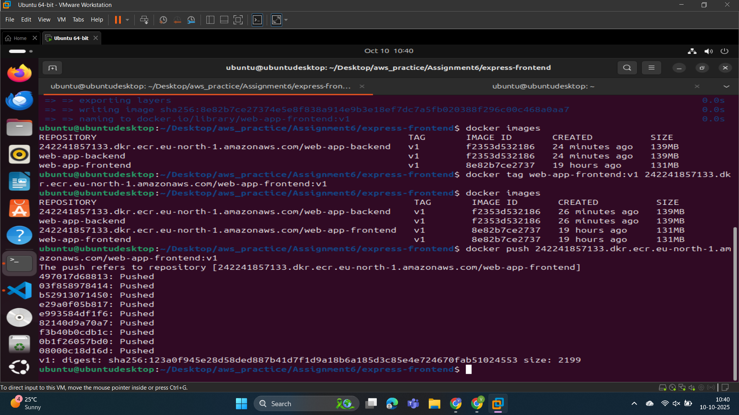

Docker image pushed success. Let's check into the repository.

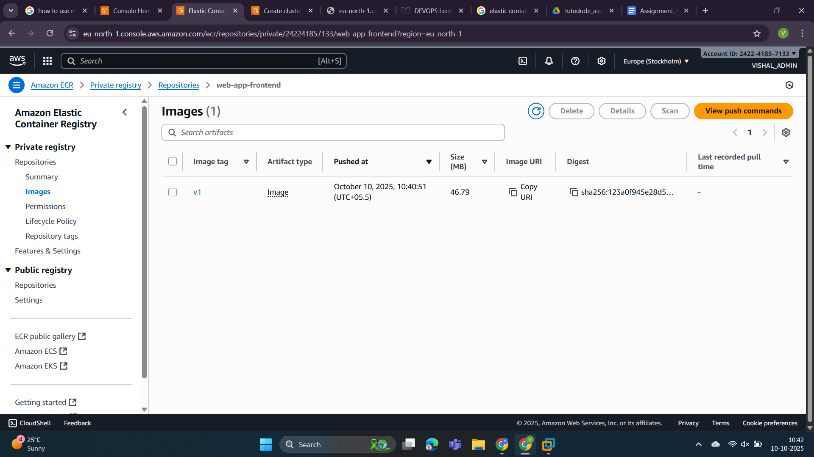

Step 2: Now open ECS(Elastic Container Service) and create a cluster there.

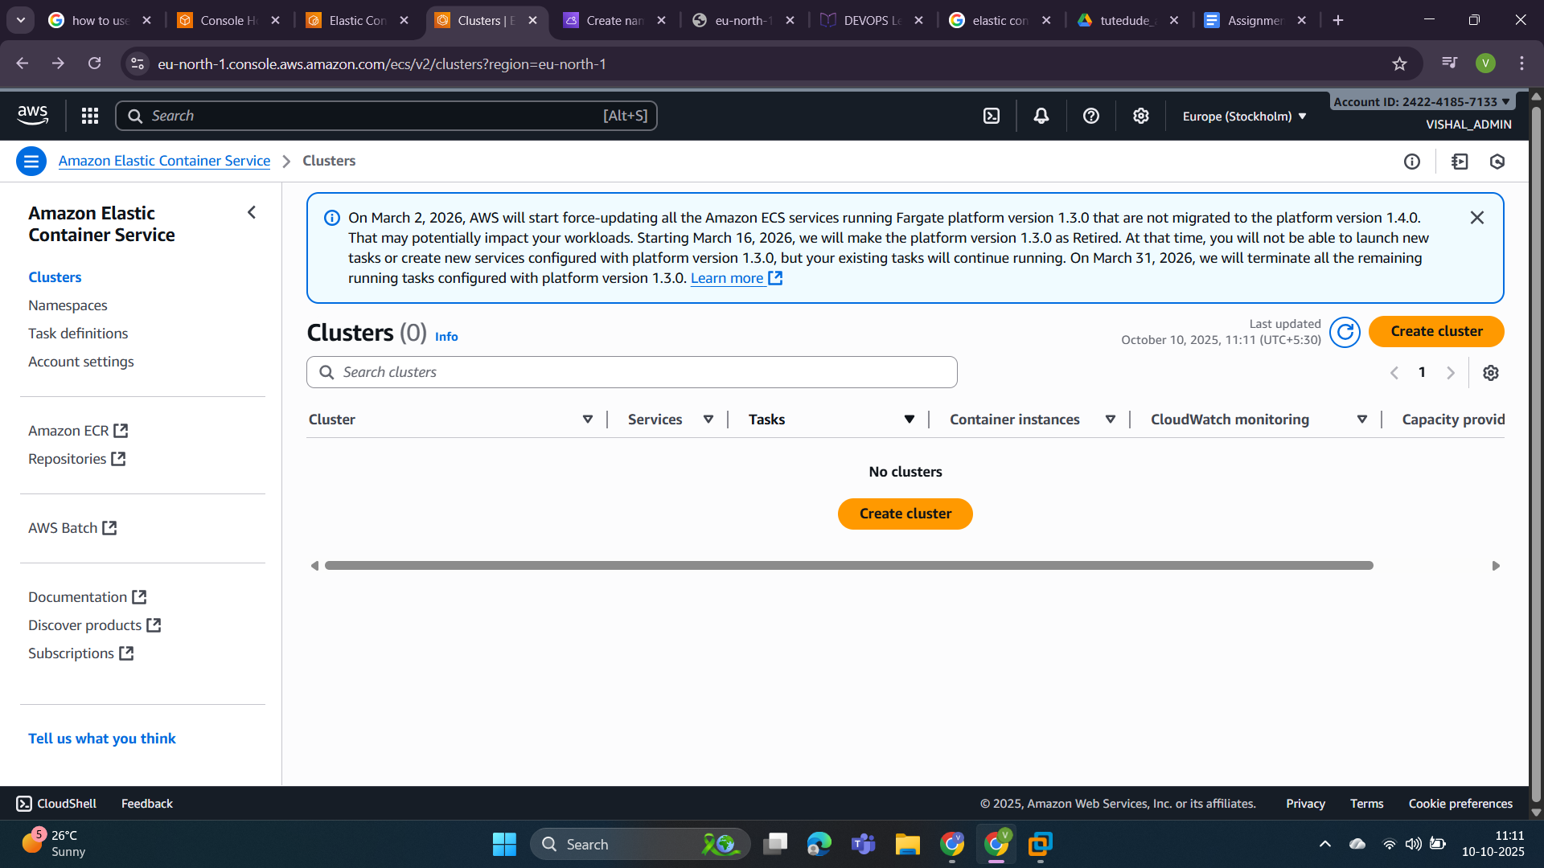

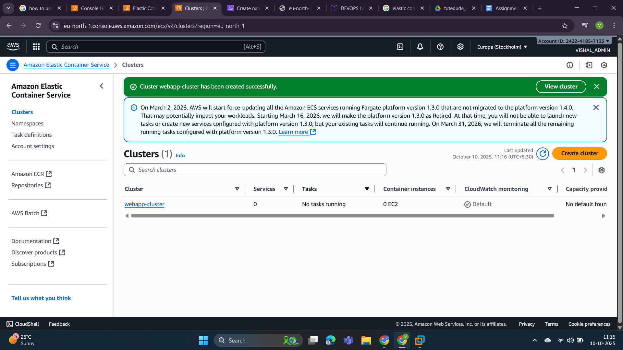

Step 3: Now create a role using IAM service so that our ECR repository can access it because they are private.

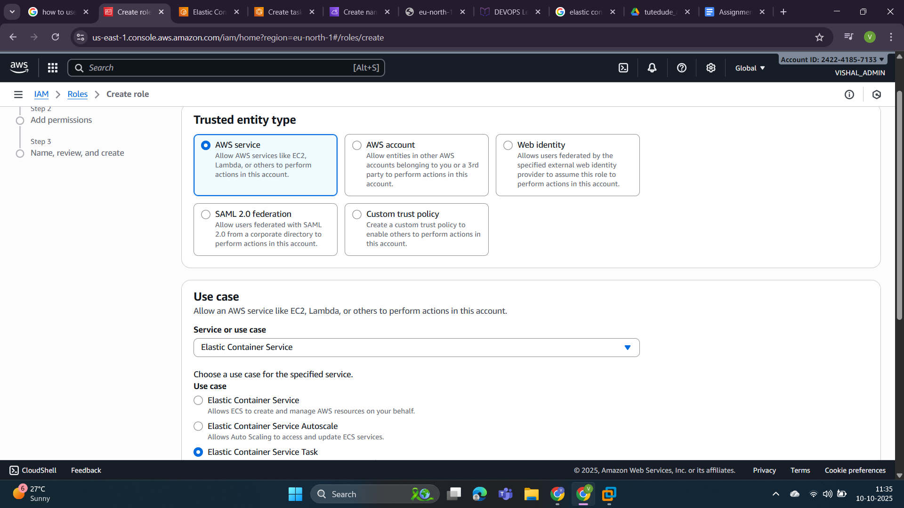

In the screenshot you can see Assigned permissions.

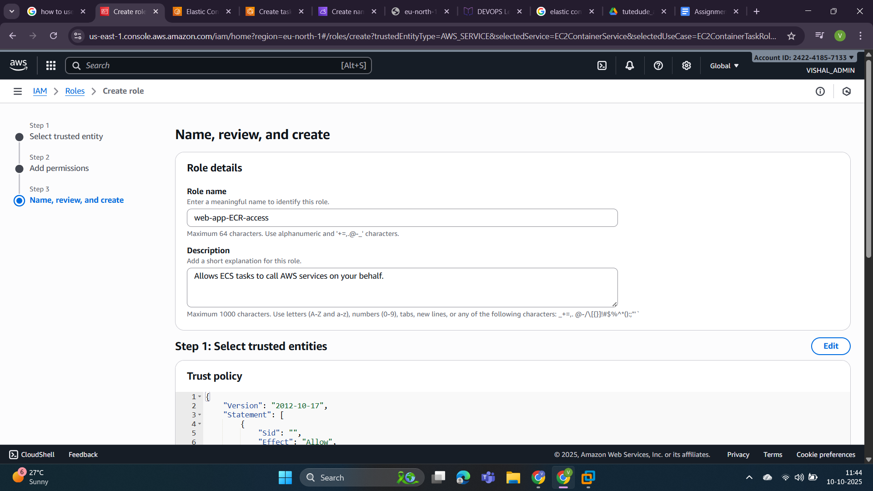

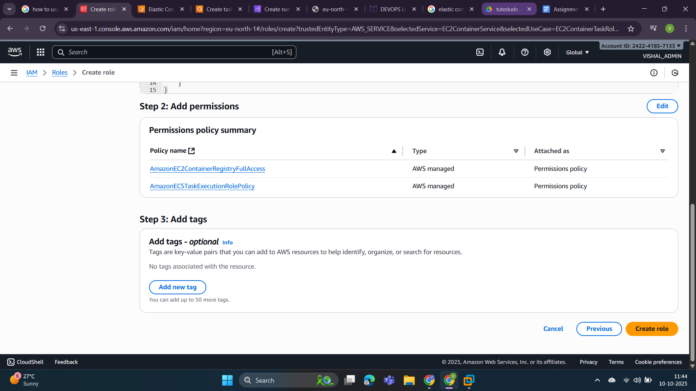

Now click on create role and this role is created.

Step 4: Now we create a task. The task name is “webapp”.

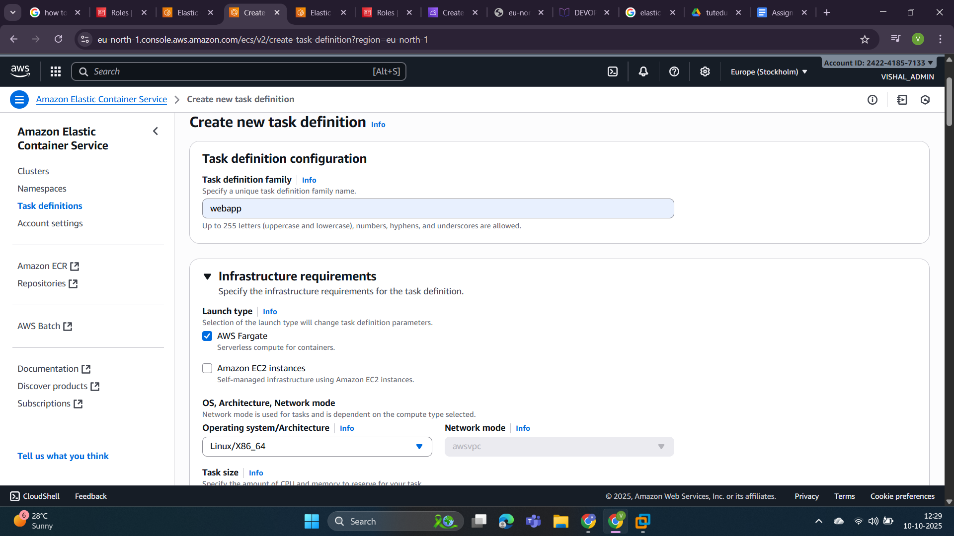

This is the infrastructure of our requirements.

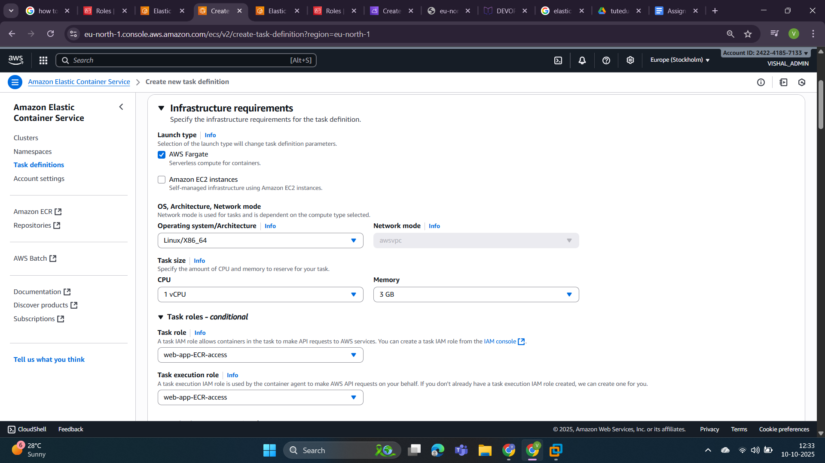

This is **container 1** for a **backend-app** that will run on **5000 port**.

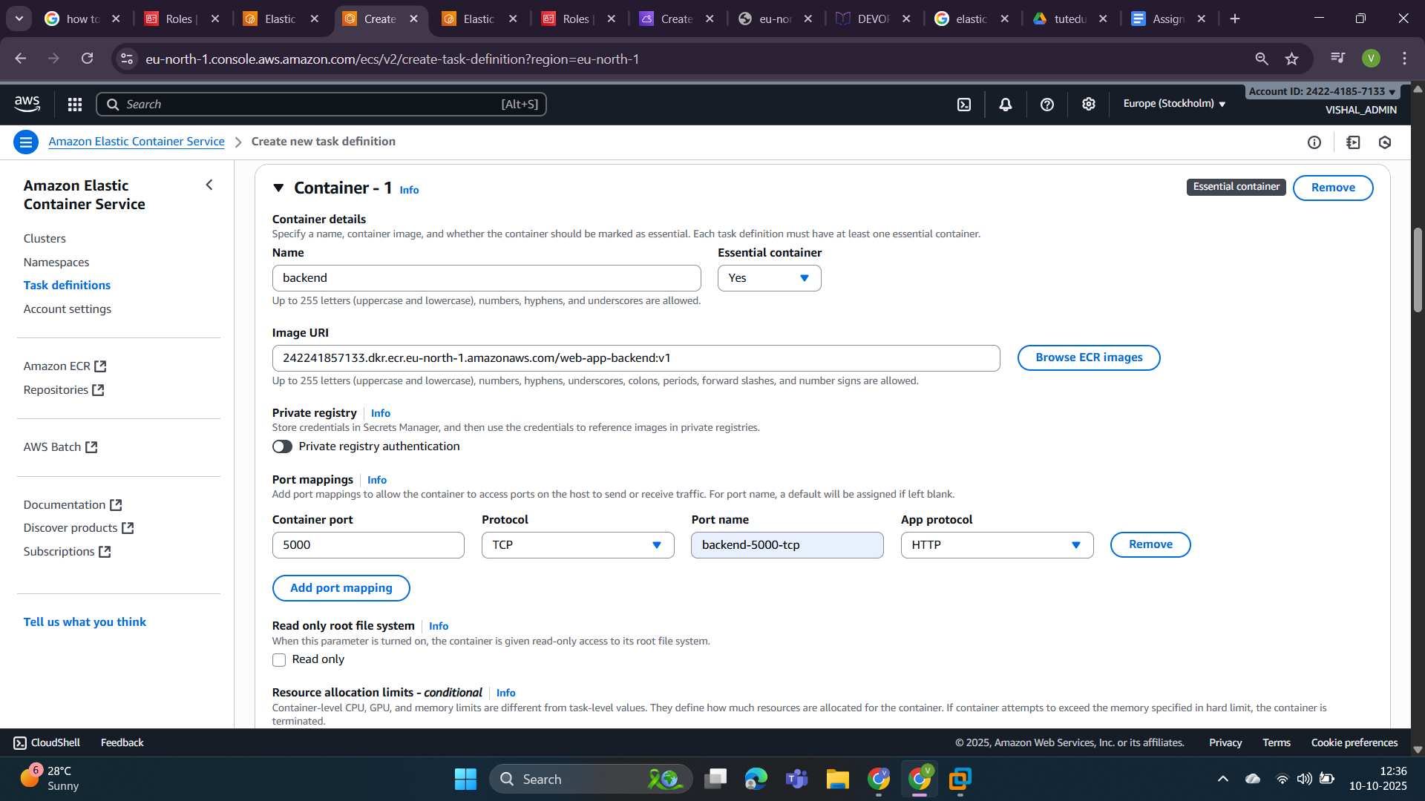

This is **container 2** for the frontend-app that will run on **3000 port**.

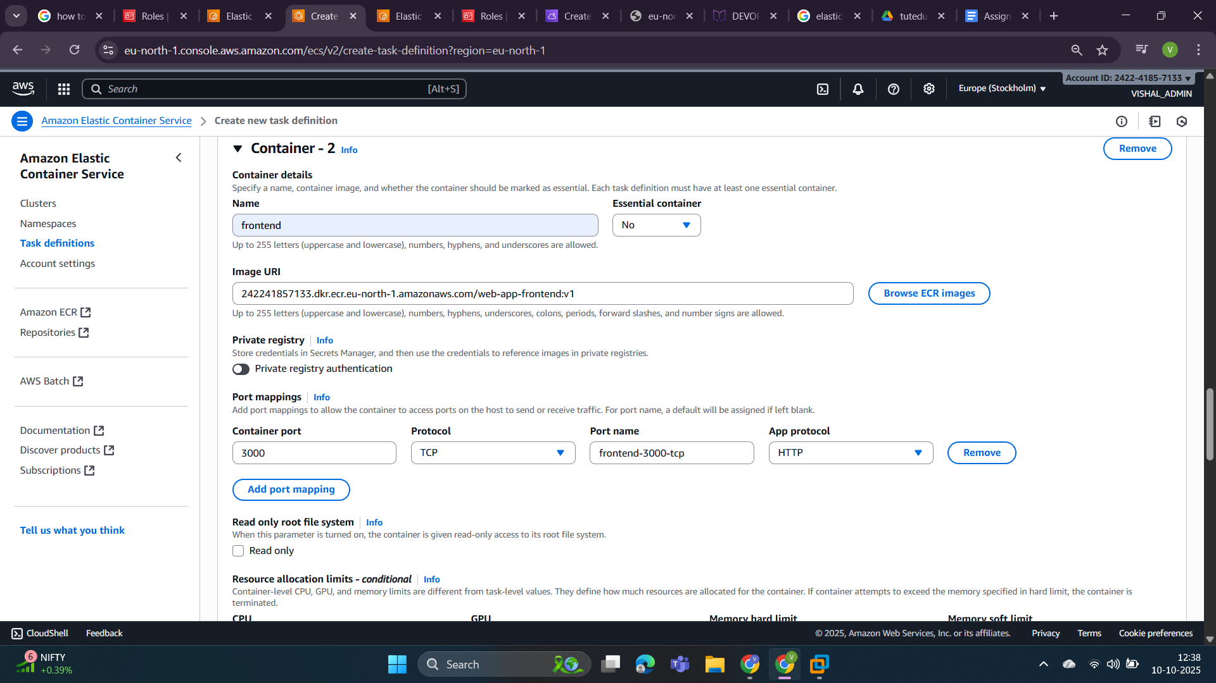

Assign one **environment** variable **API_URL.**

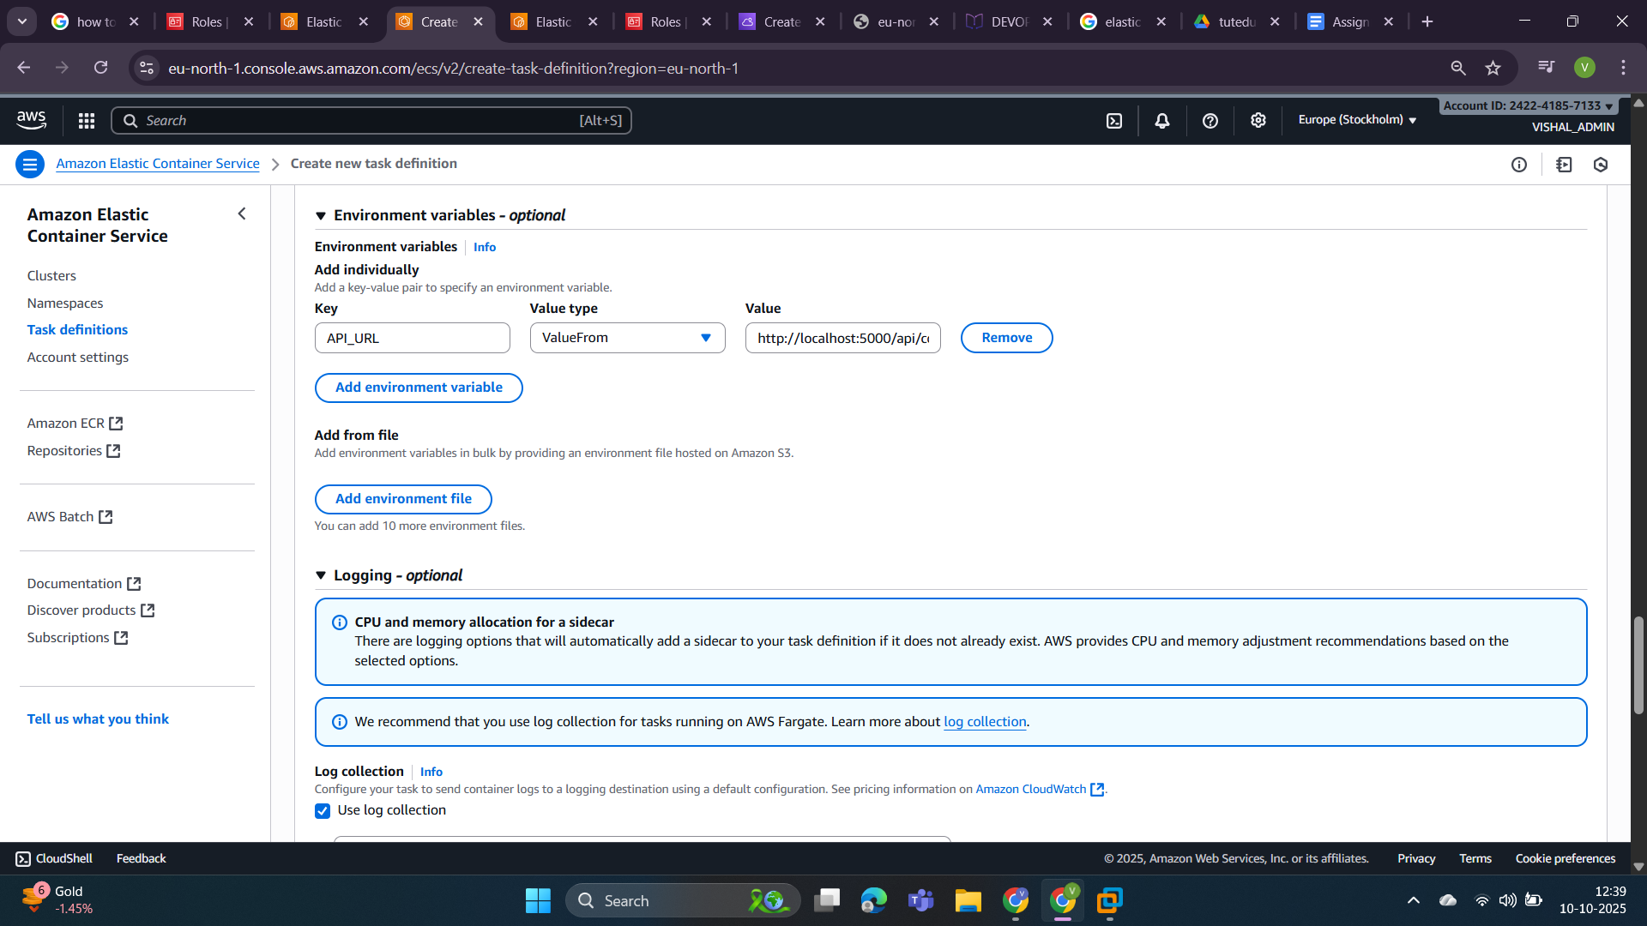

The task is created as you can see on the screen shot.  
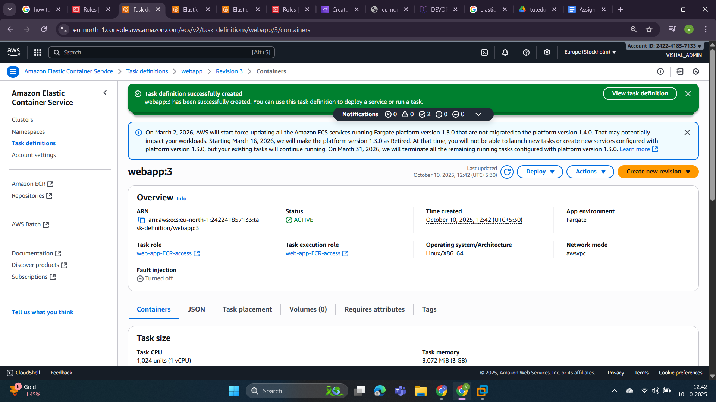

Step 5: Now click on clusters and select cluster name “webapp” and create a service inside it that will call our tasks that are created now.

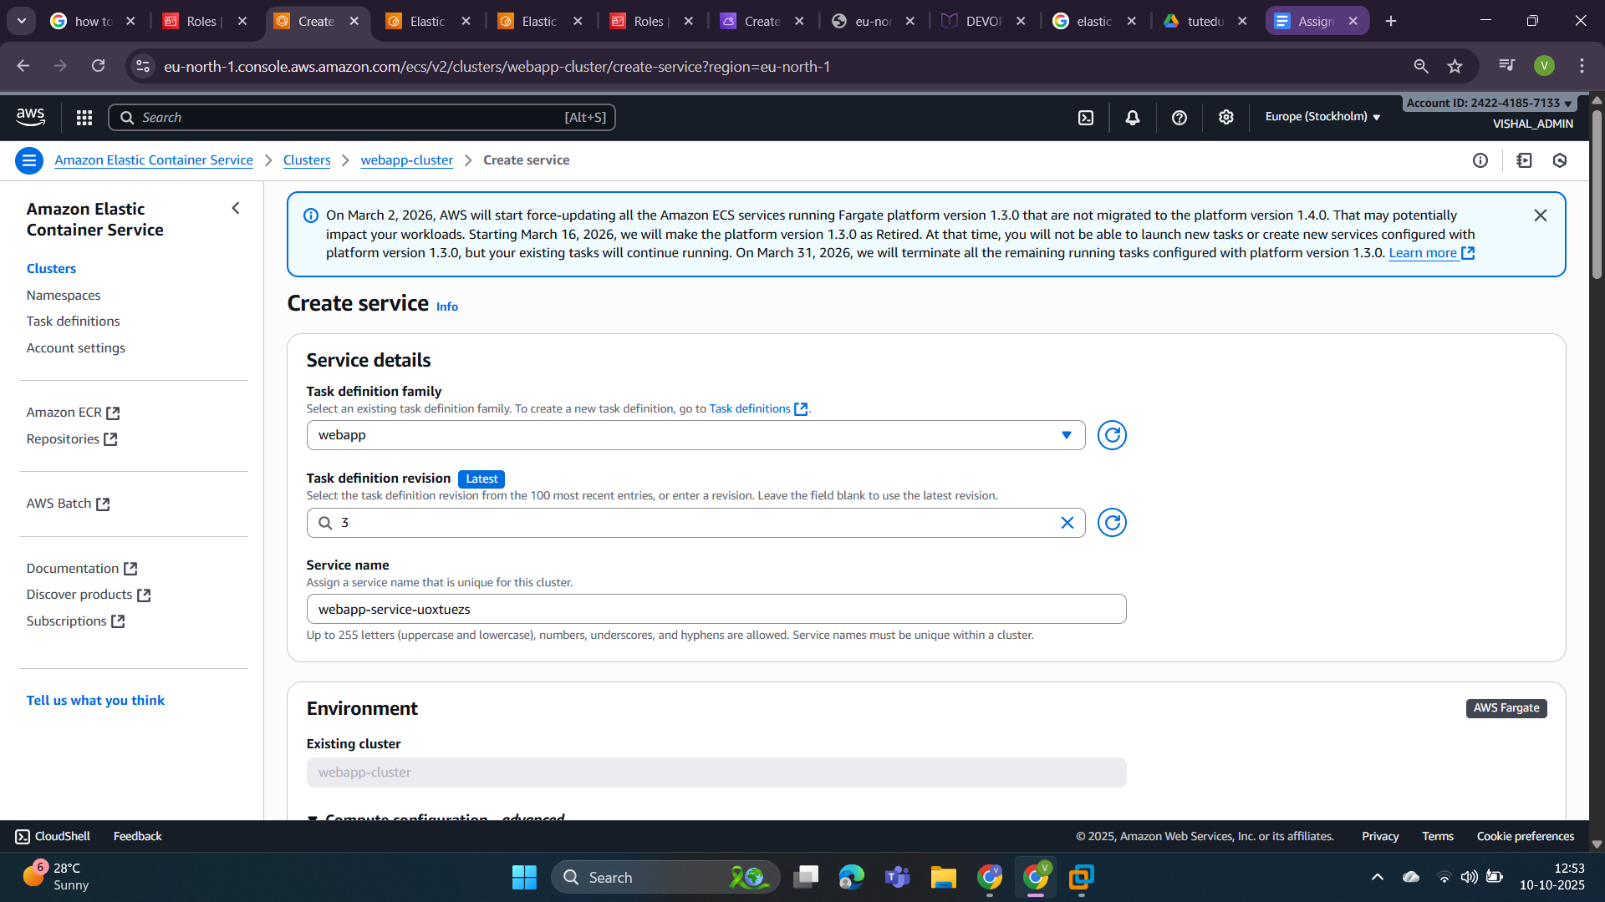

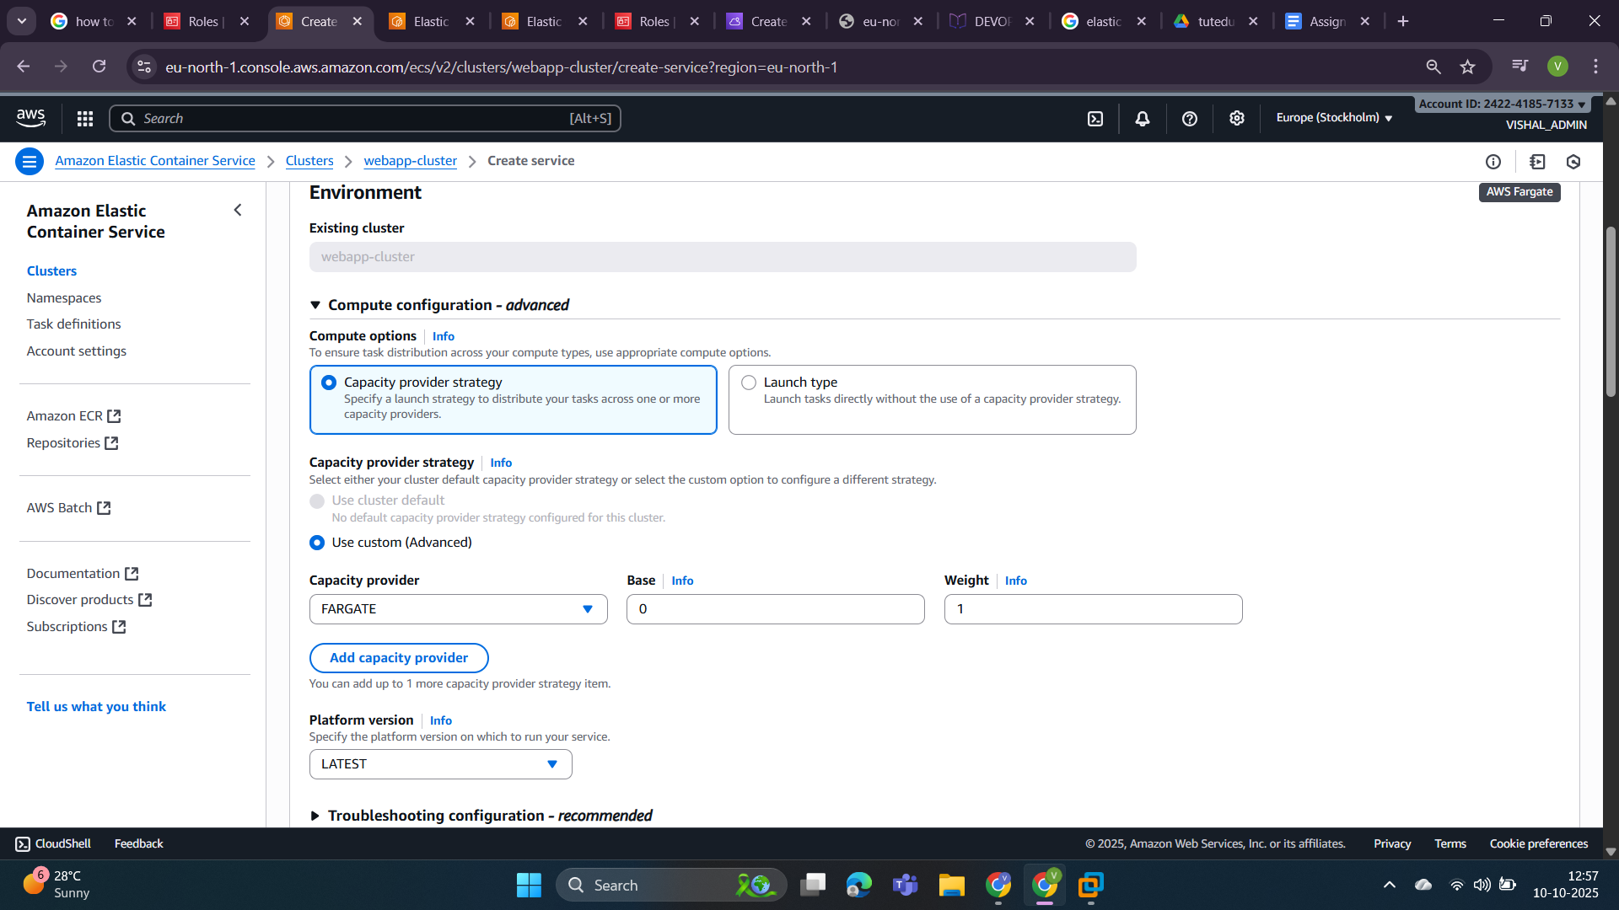

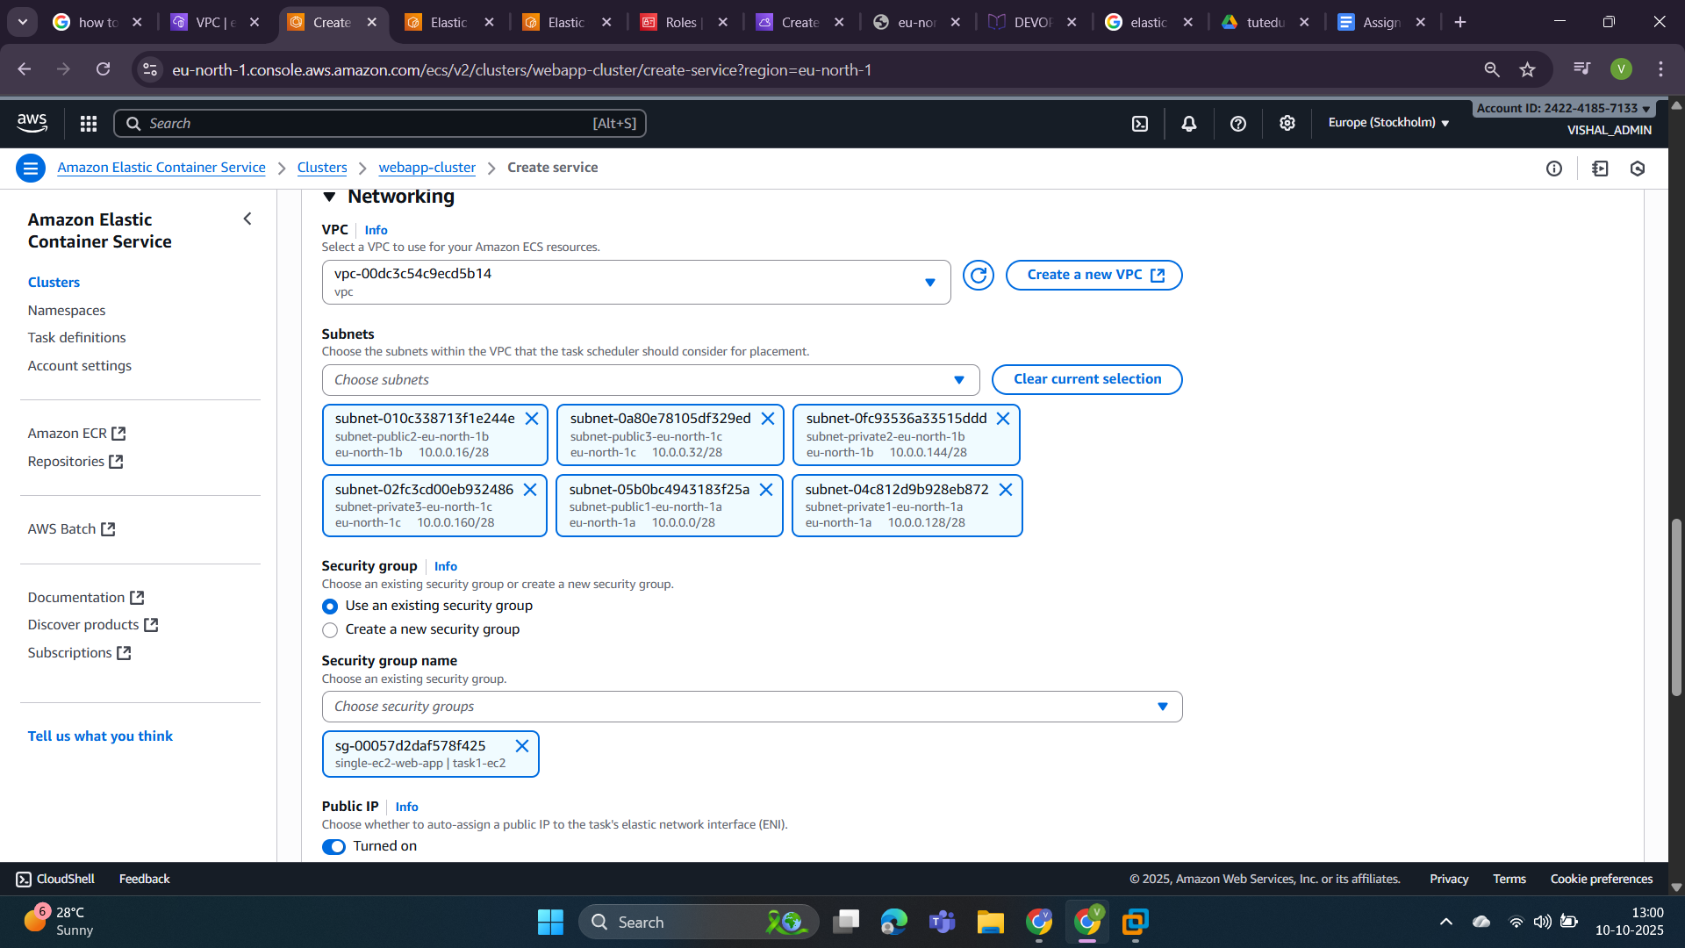

Now click on the create button.

You can see our services have been created successfully and running right now.

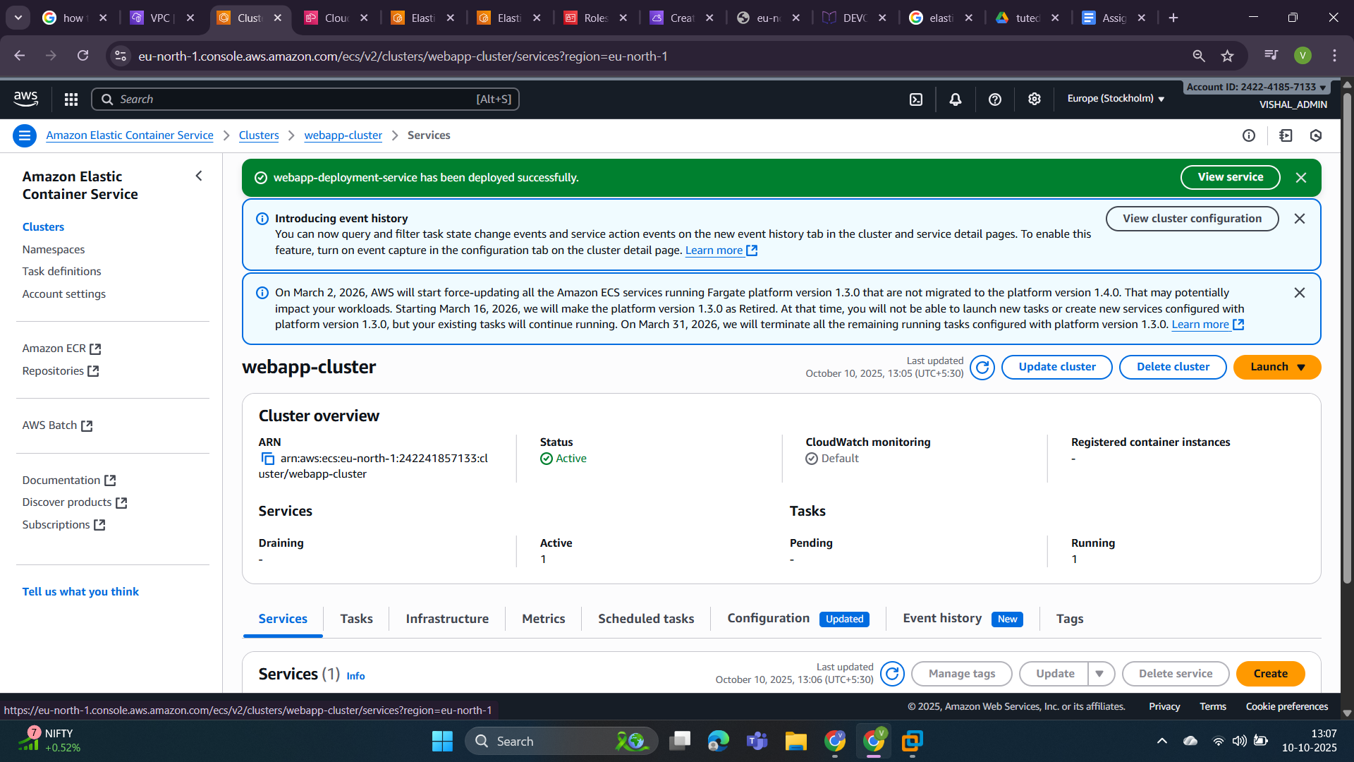

In the cloudformation we can see all events has done successfully.

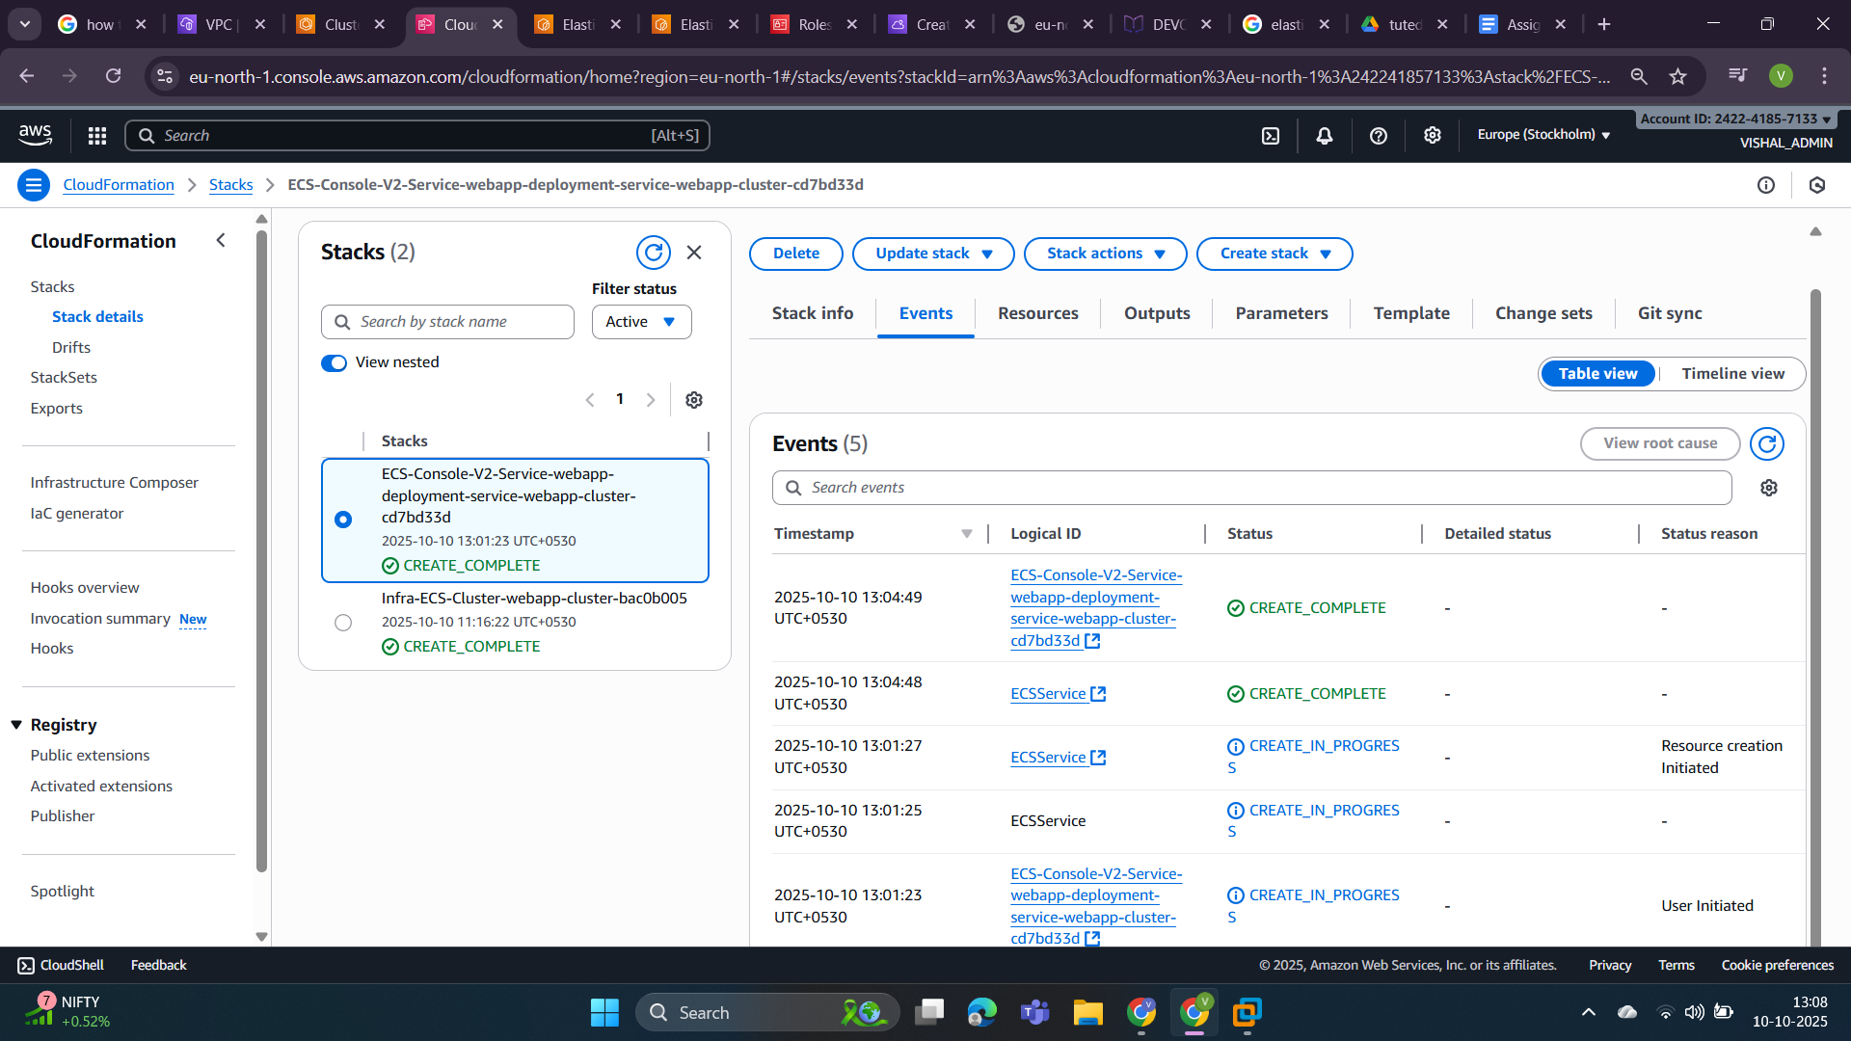

Step 6: Now find a **“Public IP”** so that we can access the running task. In the below screenshot **Public IP is 13.51.178.8.**

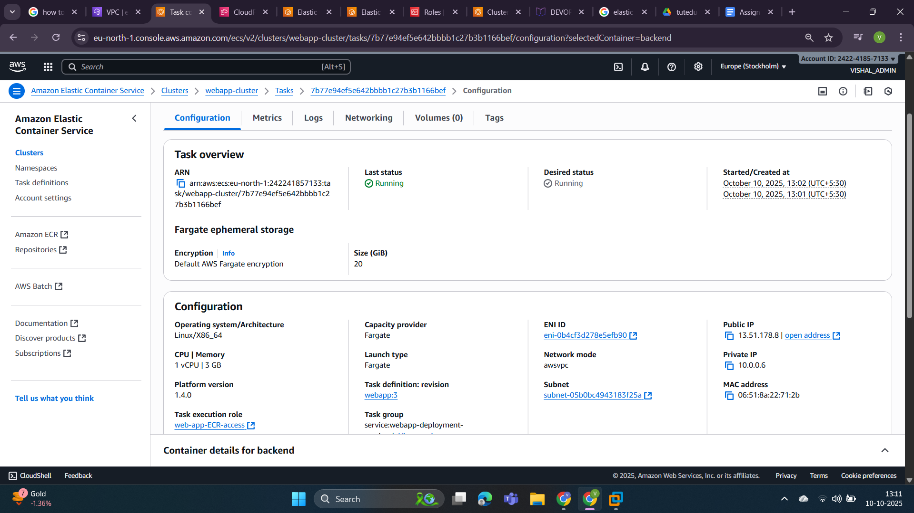

Step 7: Now access our webapp using this ip in the browser. And in the below screenshot we can see our project running well.

* Frontend url is-> **19.51.178.8:3000**

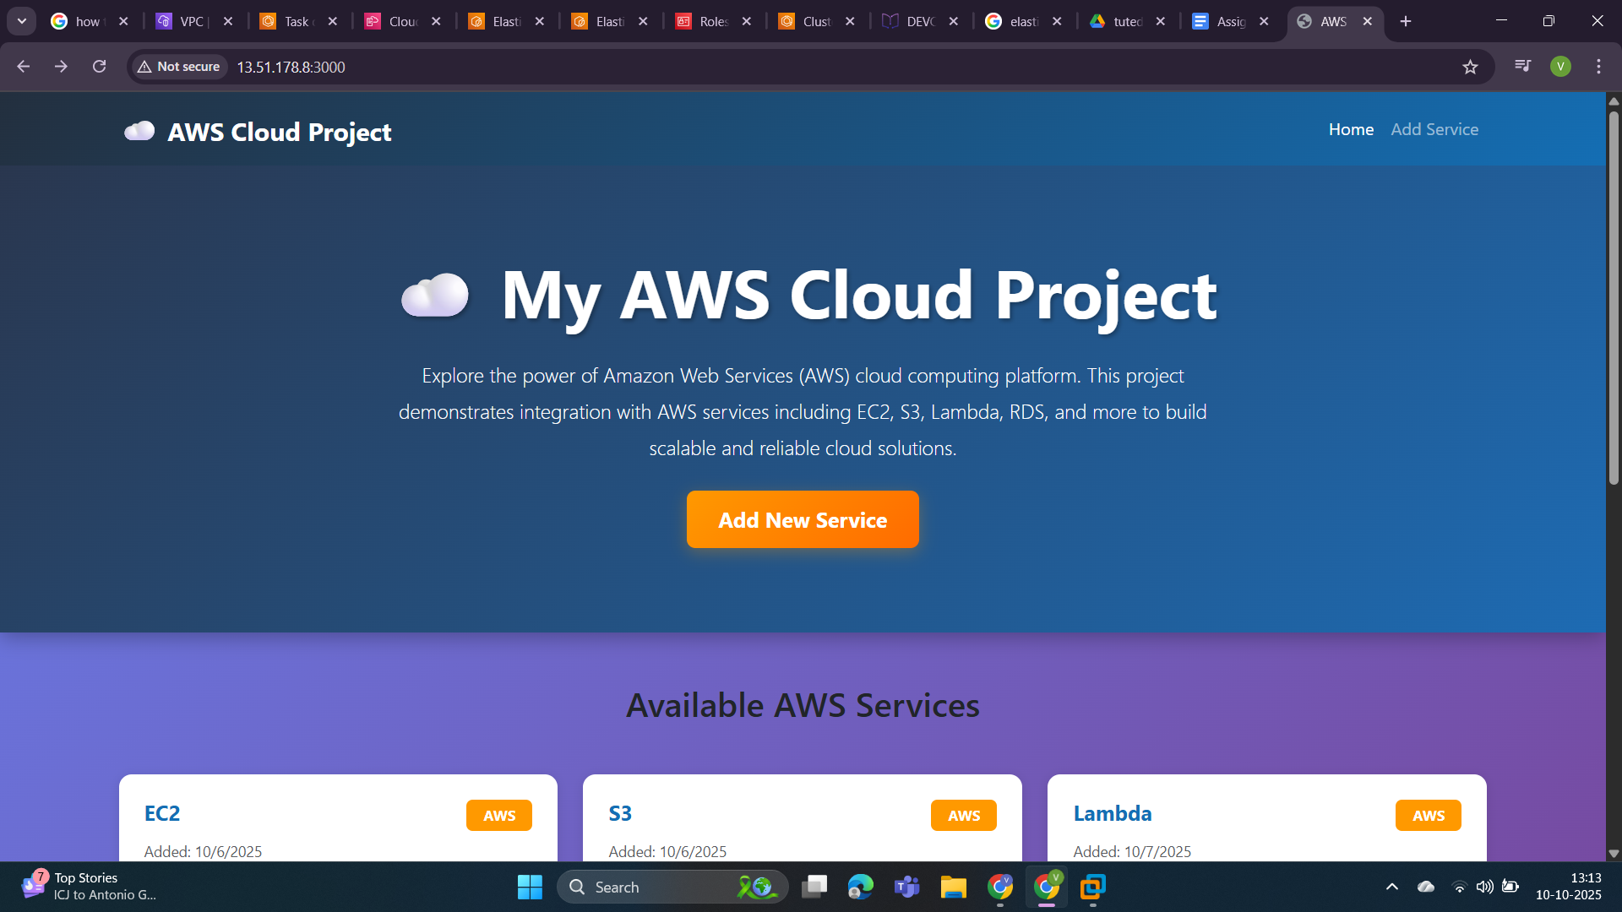

* Backend url: **19.51.178.8:5000/api/health**

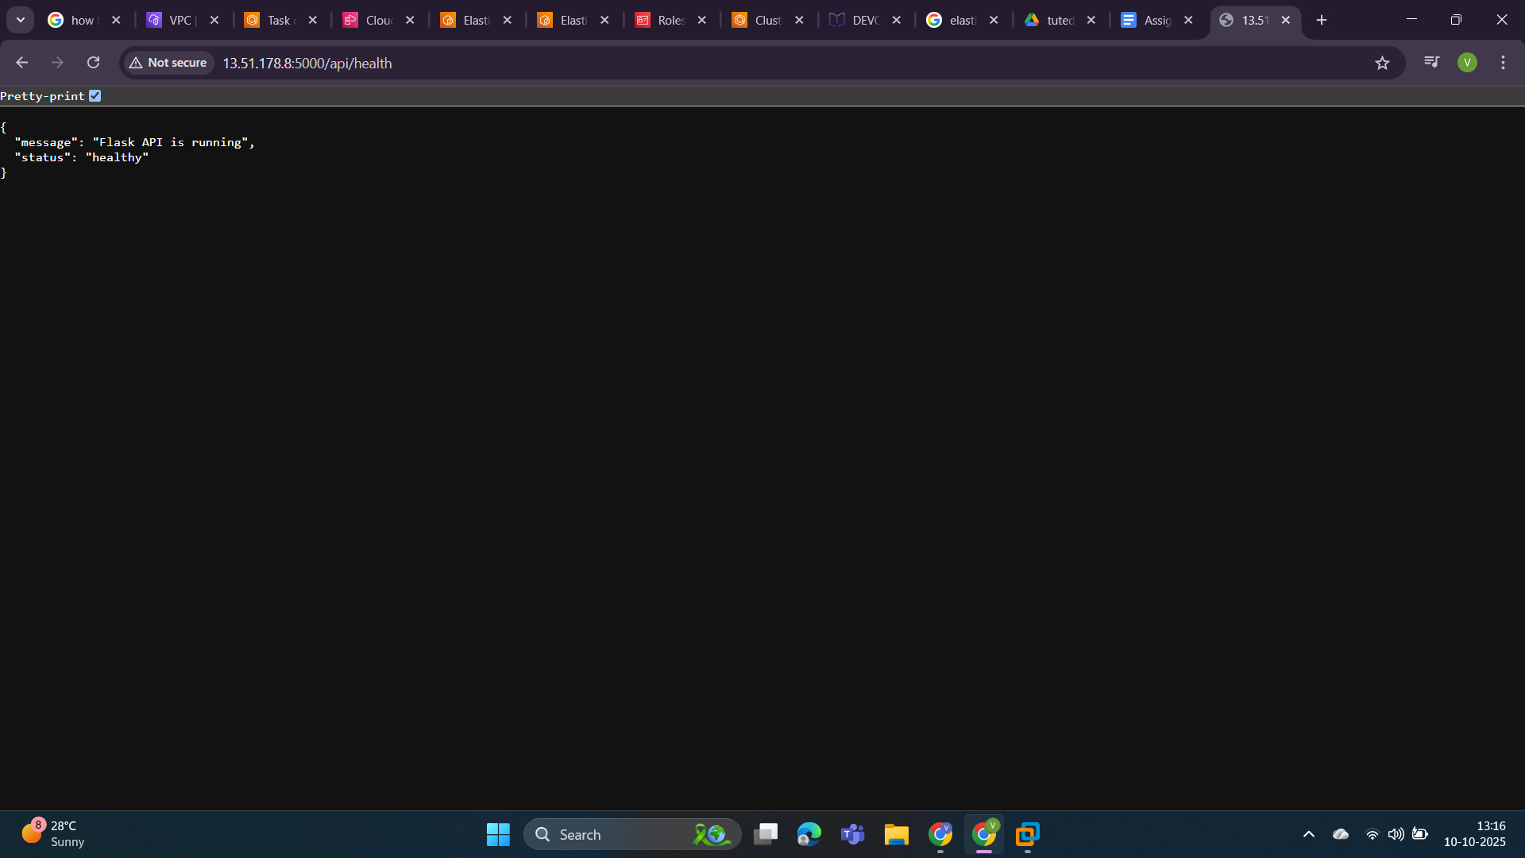  
url-> **19.51.178.8:5000/api/services.**

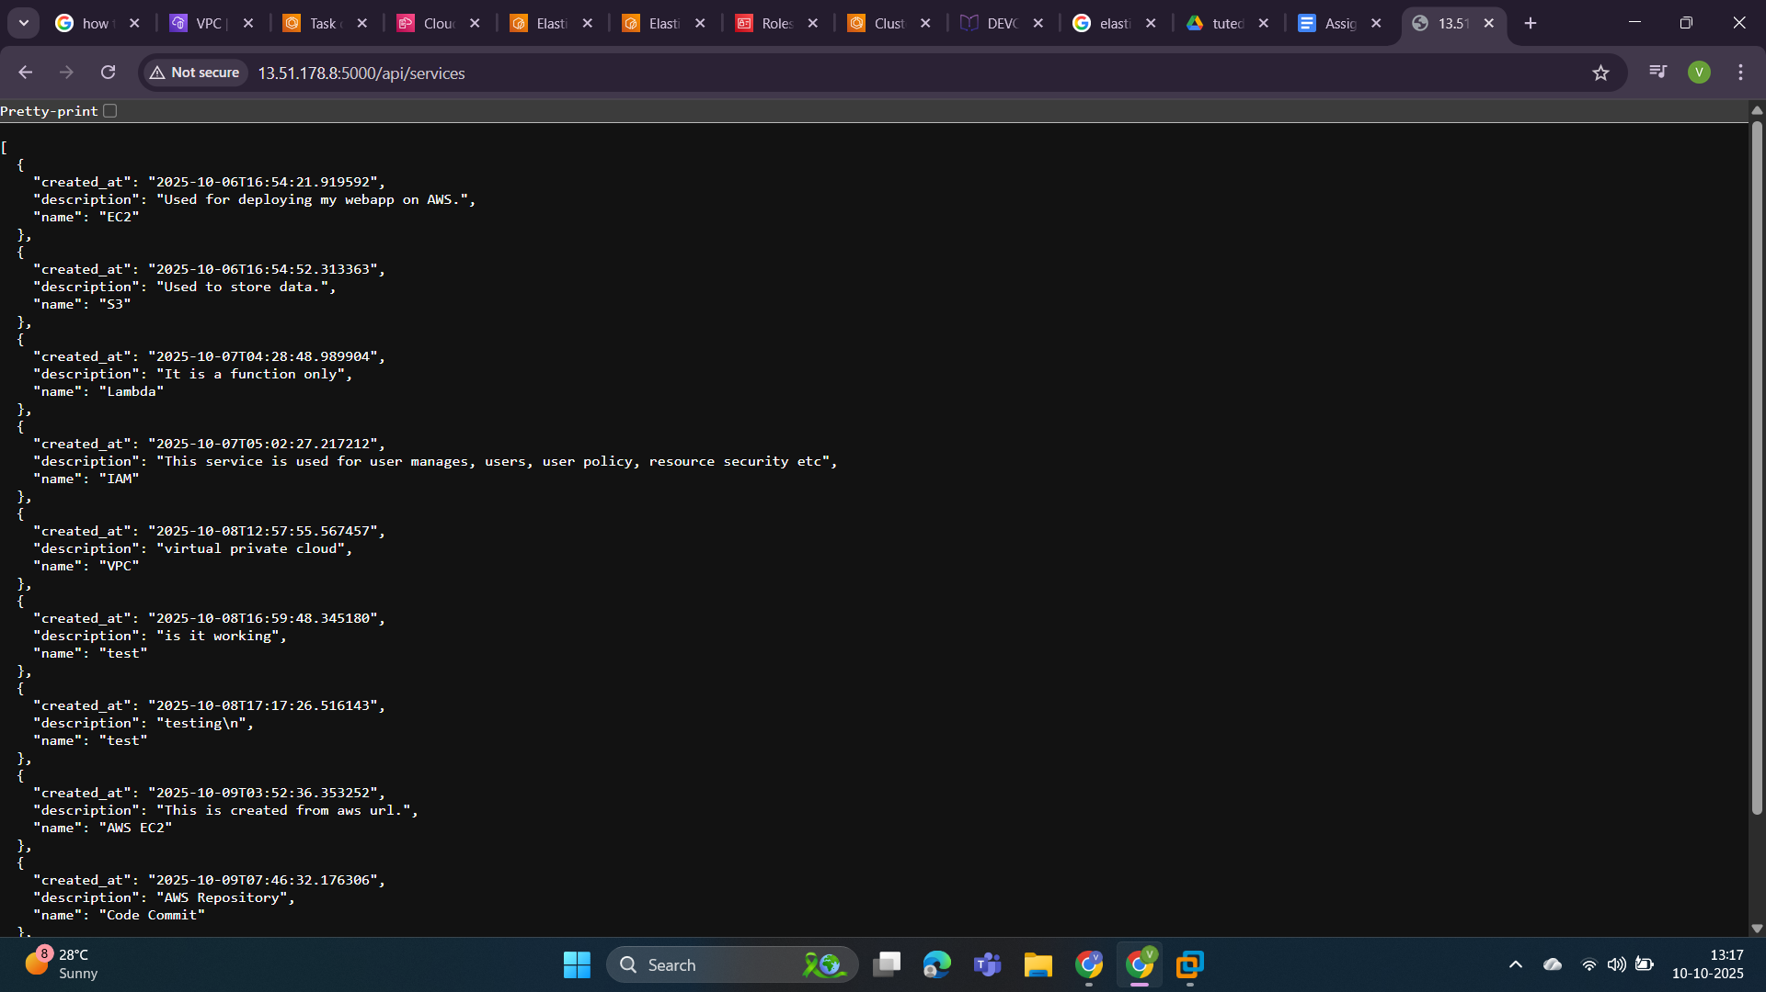

2. Deploy Your flask backend and express frontend in separate ec2 instances.

Ans:

I am doing this task with the help of AWS “CloudFormation” service.

Step 1: Create key pairs for both EC2 instances frontend and backend.  
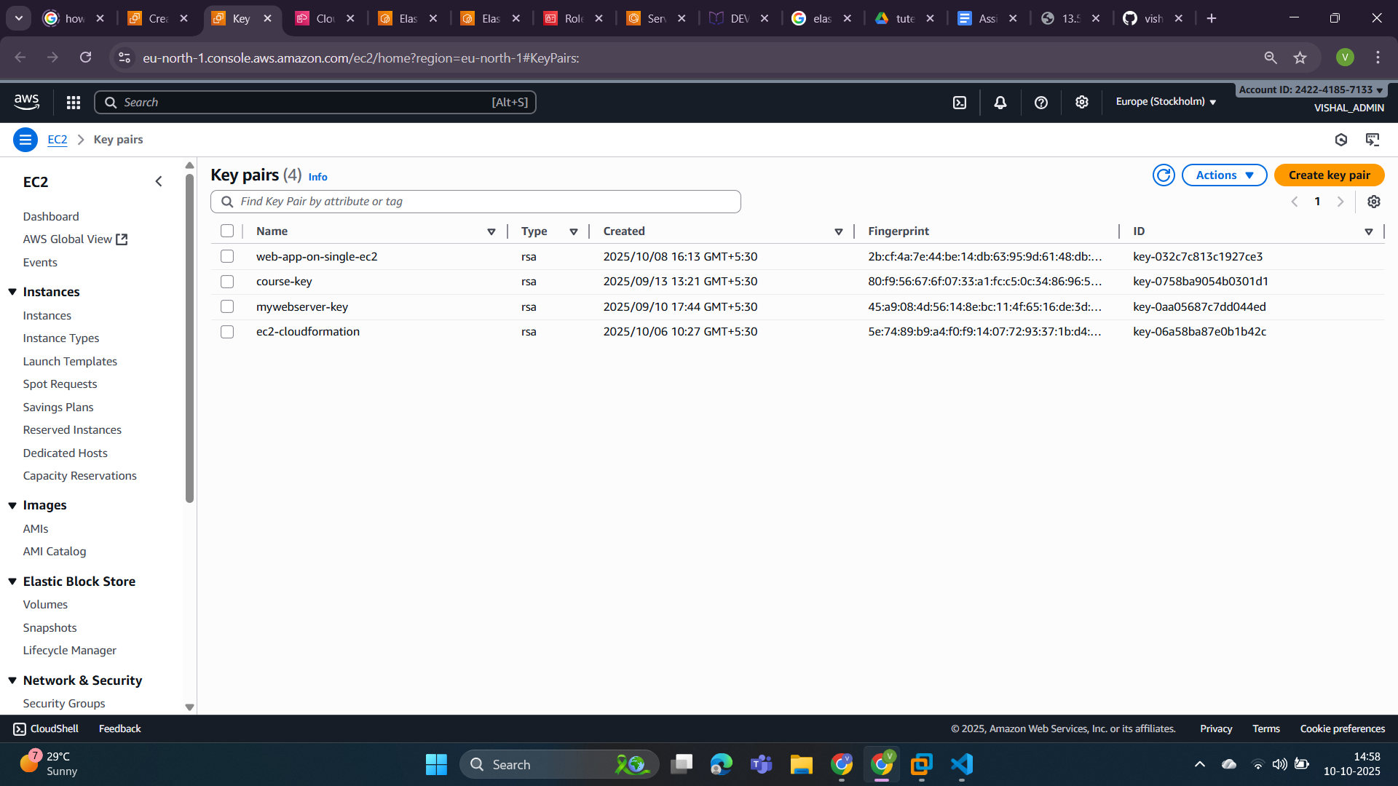

* Frontend-key: This key is created to access instance1 where our frontend application will deploy and run.

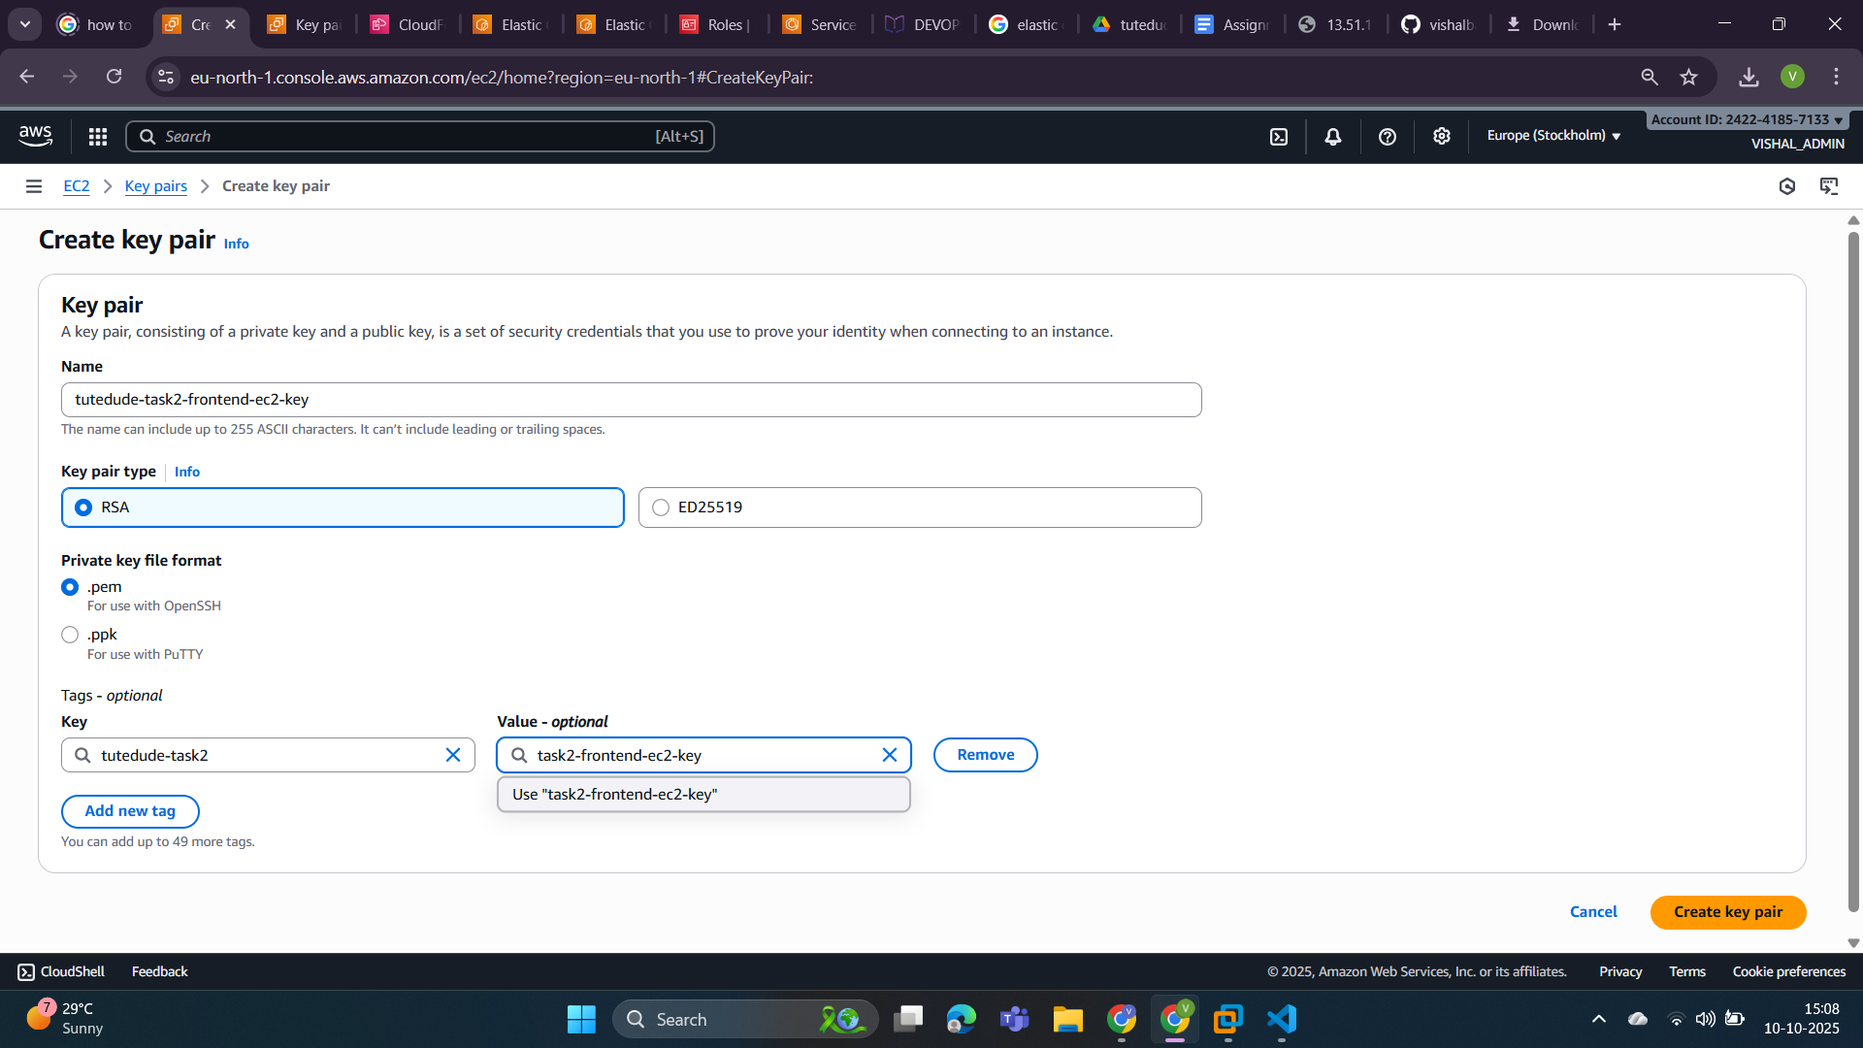

* Backend key:This key is created to access instance2 where our backend application will deploy and run.

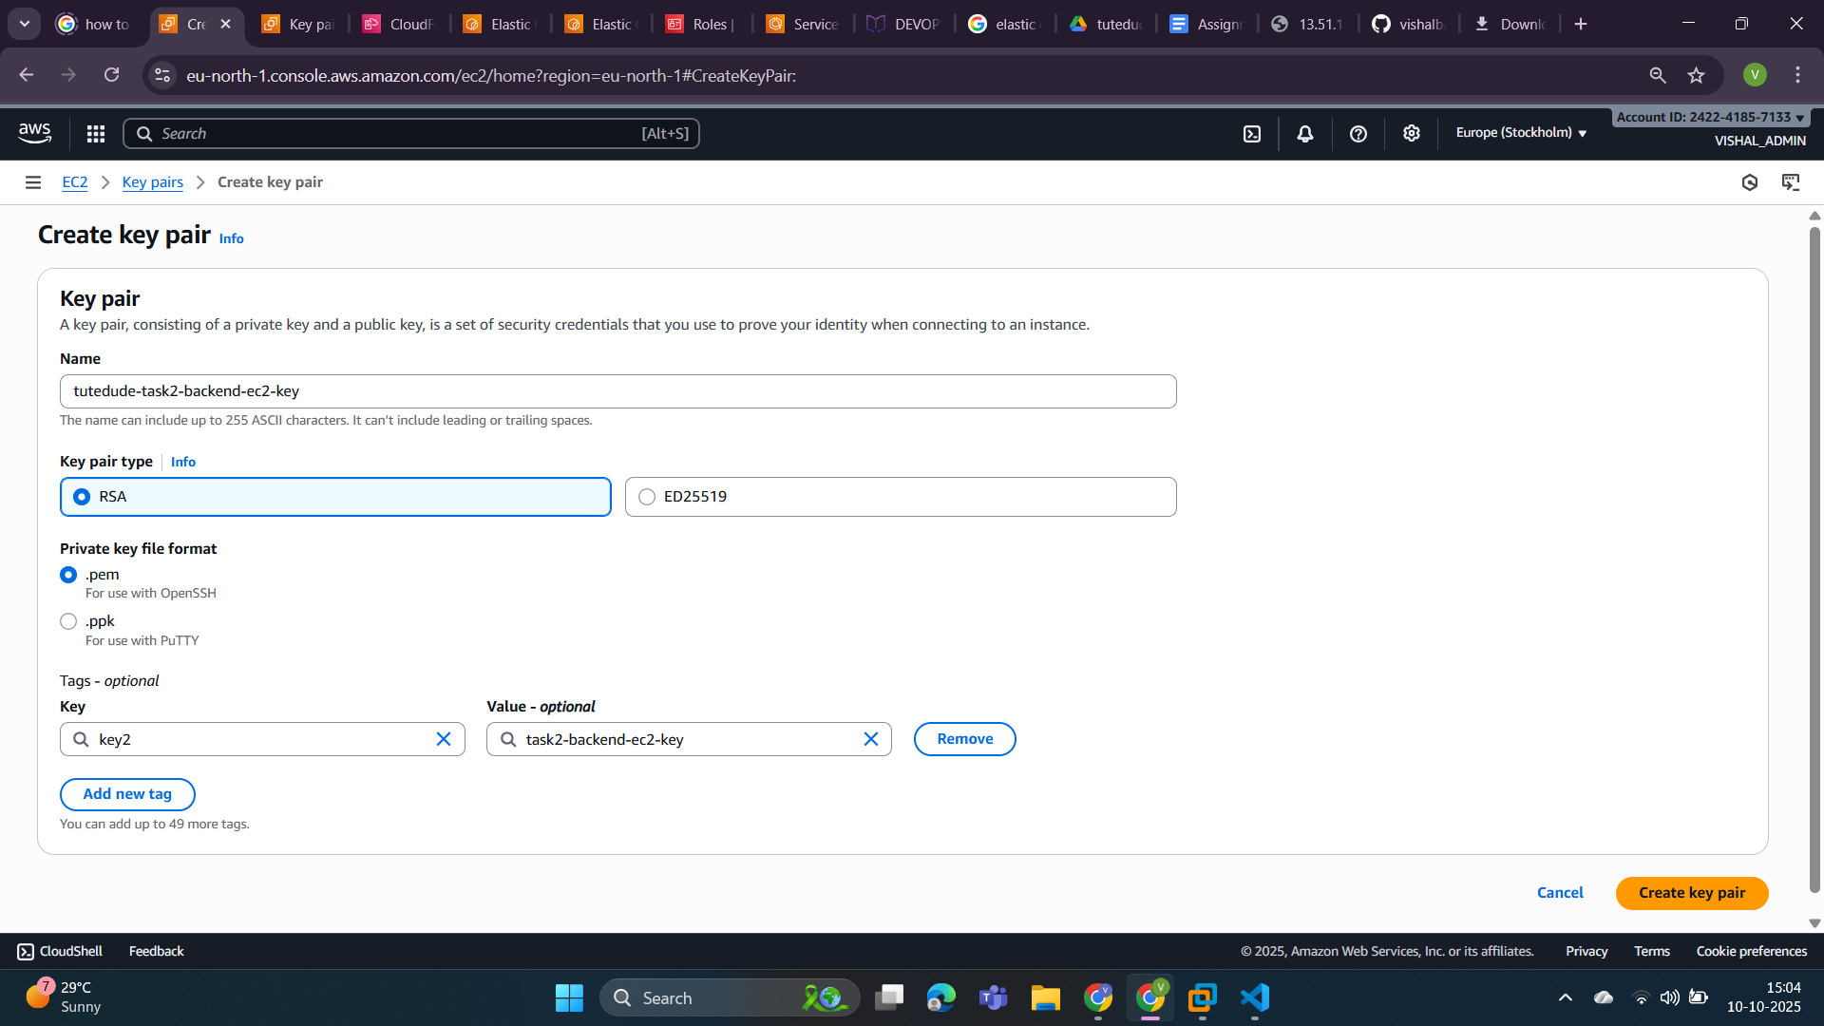

You can see we have created two key pairs to connect with our EC2 instances.

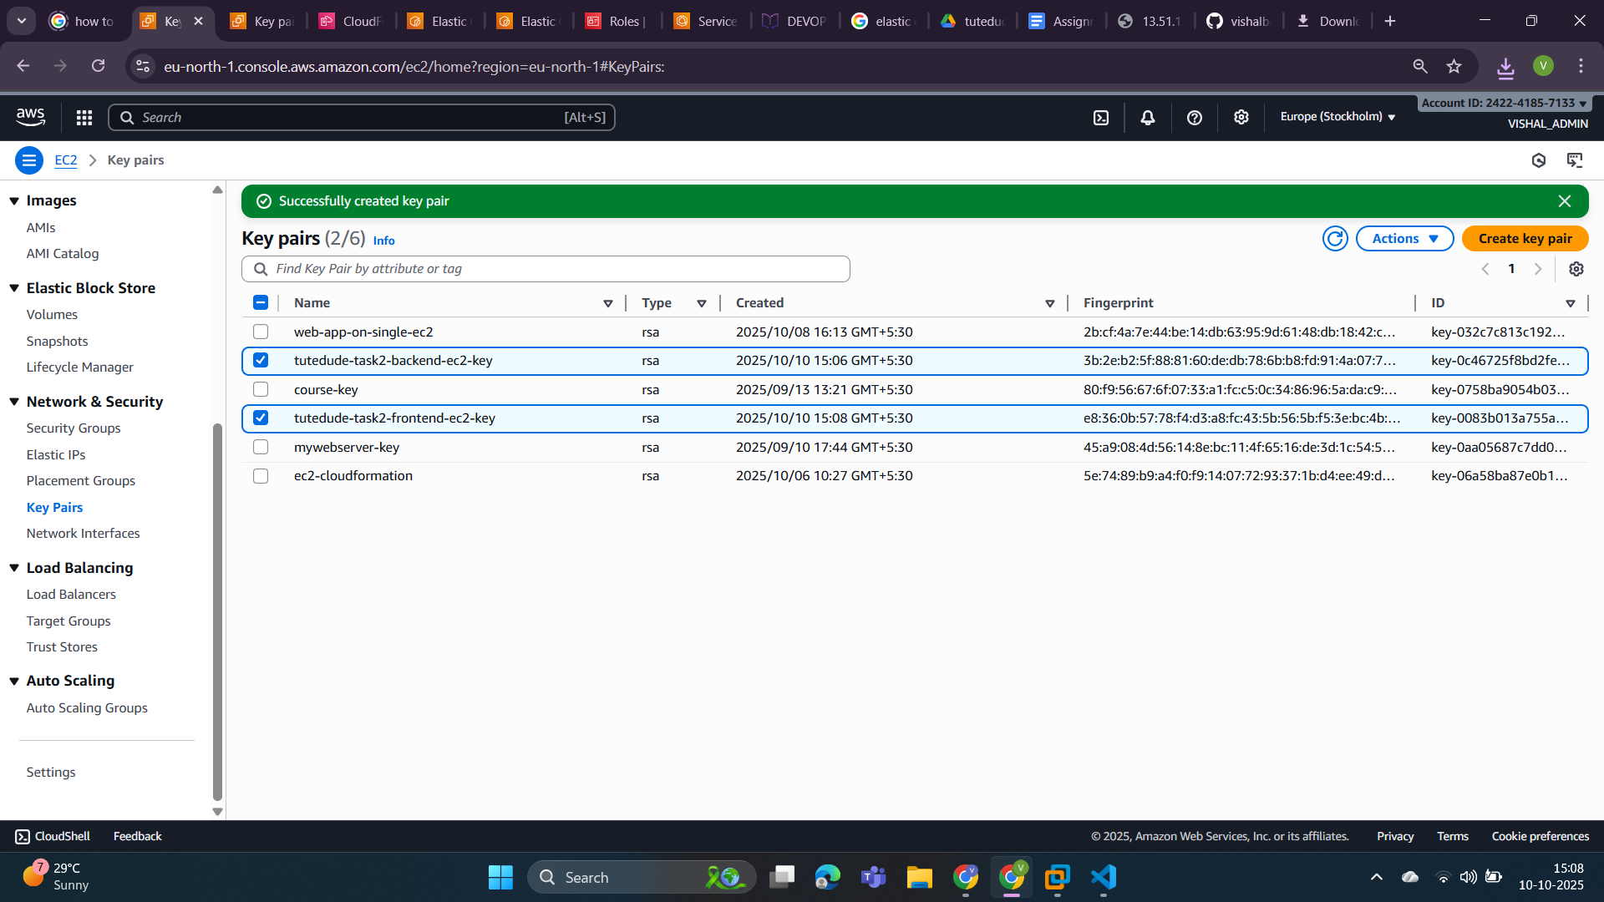

Step 2: Get the security group name from the listed security group as you can see in the below screenshot.

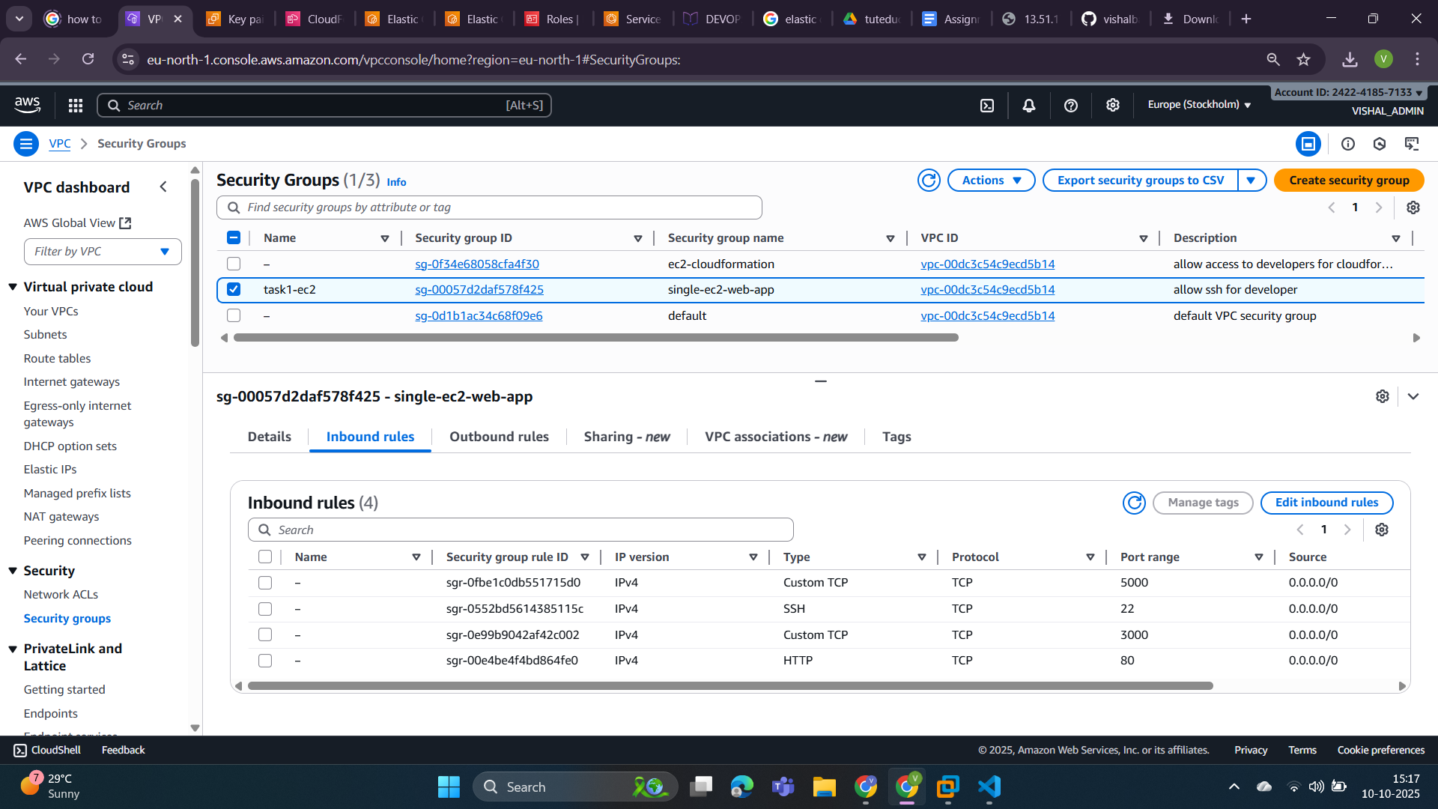

Step 3: Now I am going to create a VPC in the **Asia Pacific(Mumbai)** Region as you can see in the below screenshot.

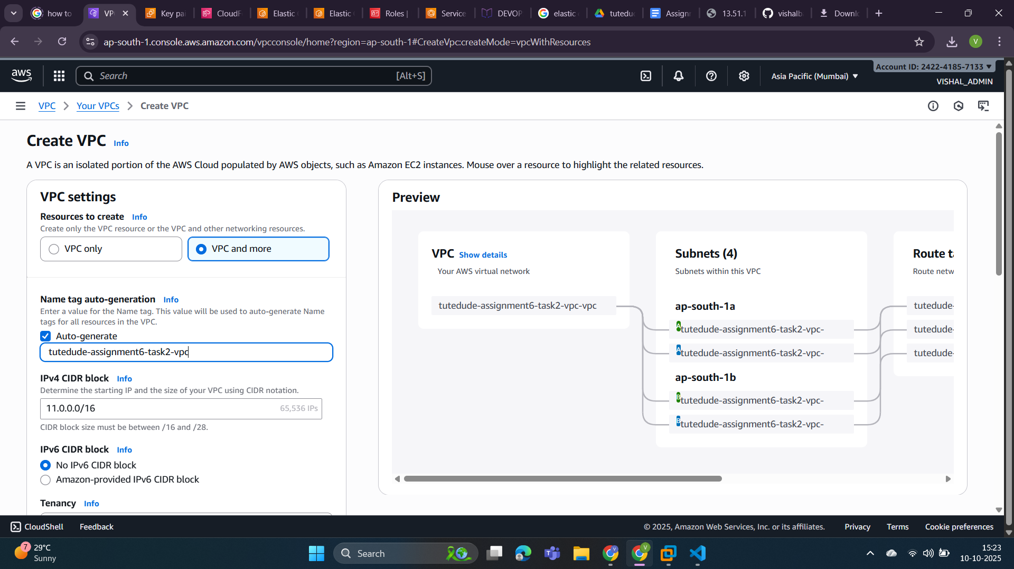

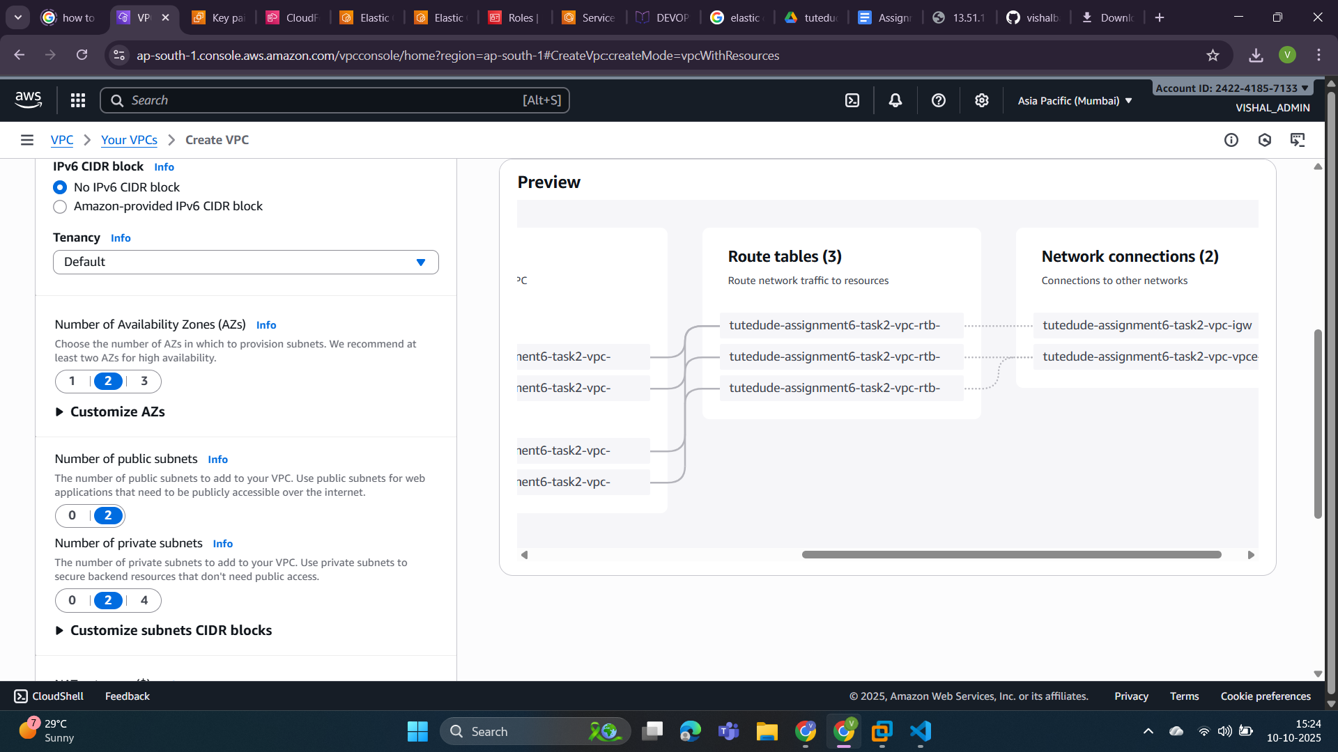

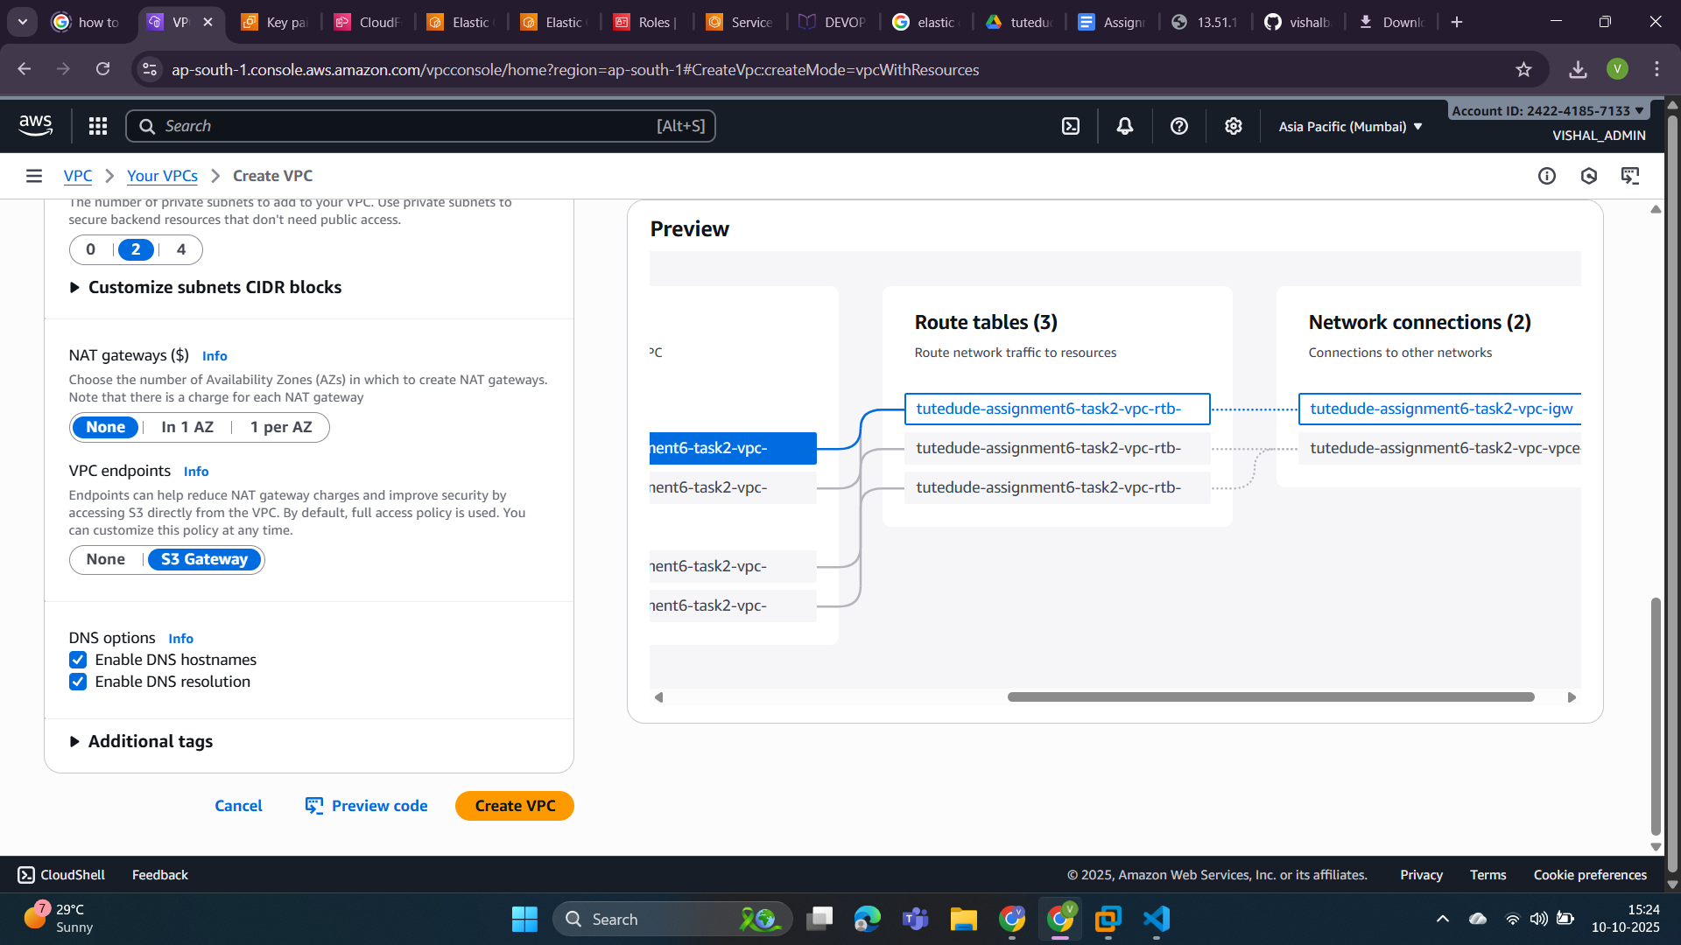

VPC Created Successfully.

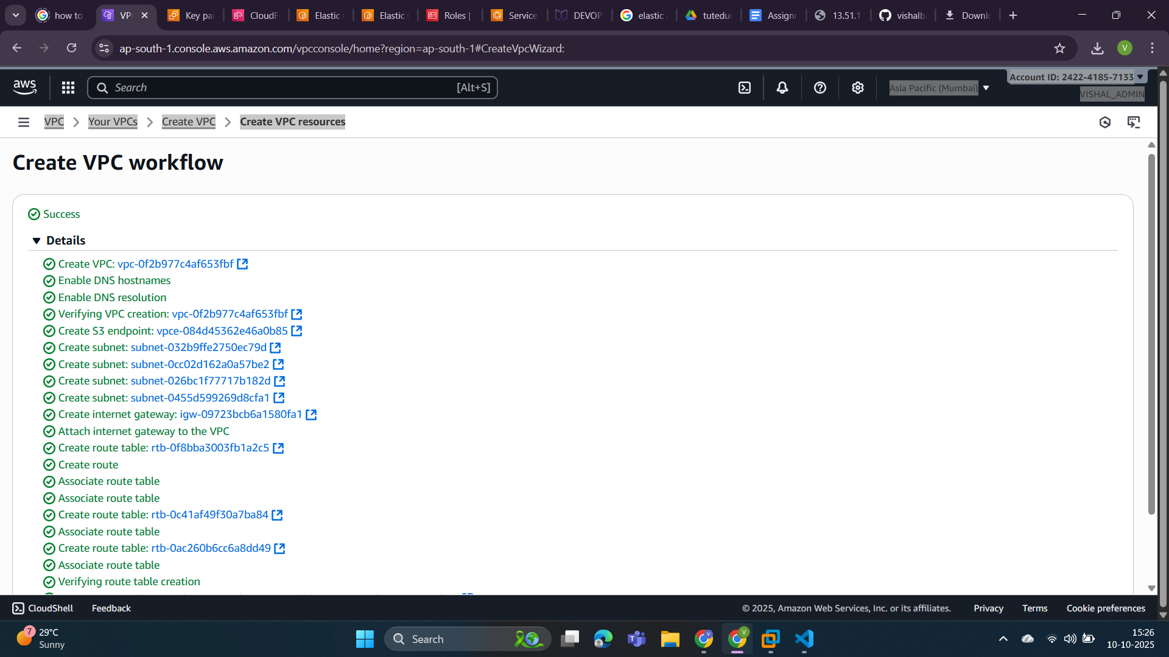

View created VPC.

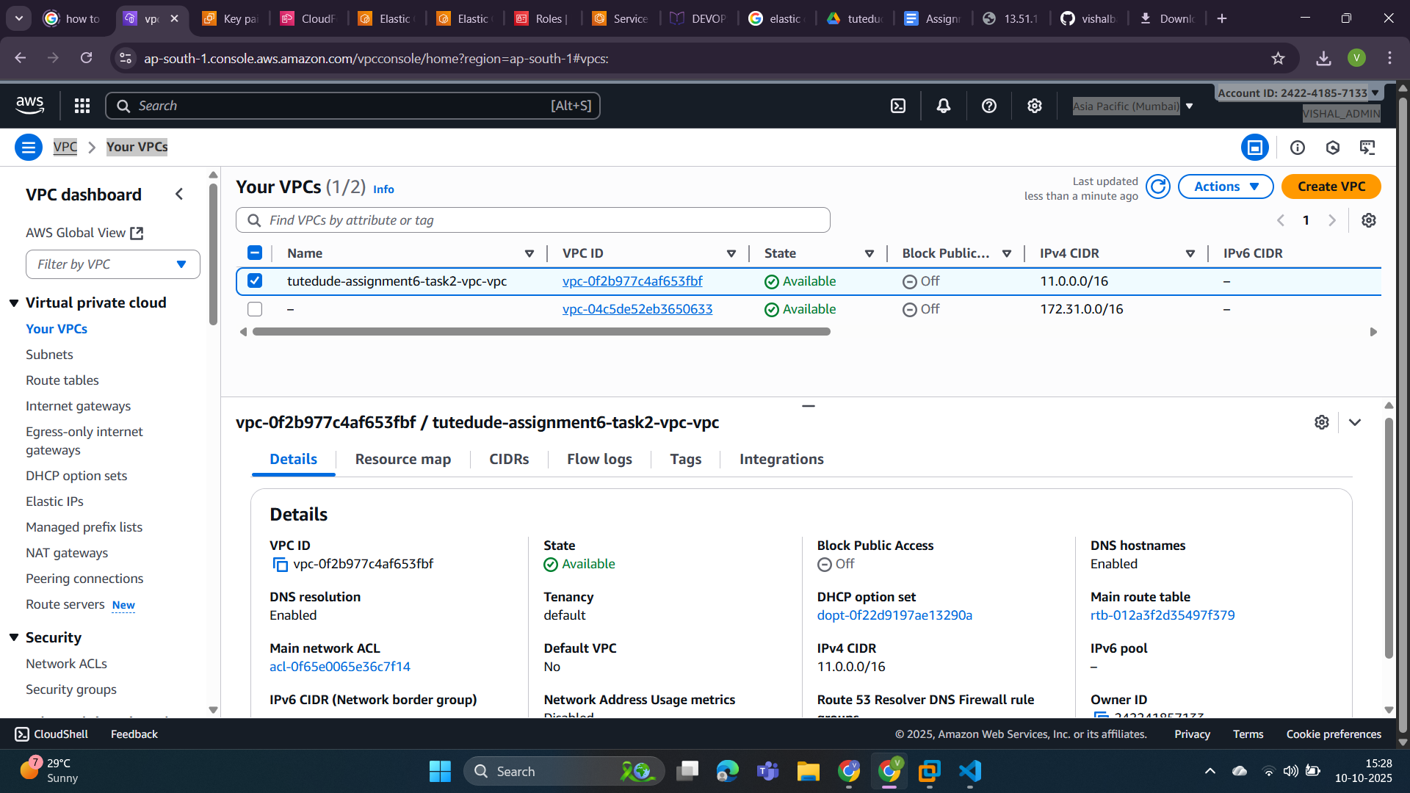

Step 4: Template code for cloudformation.

This is the starting point of our cloudformation template code. This section shows all the parameters used to create EC2 services.

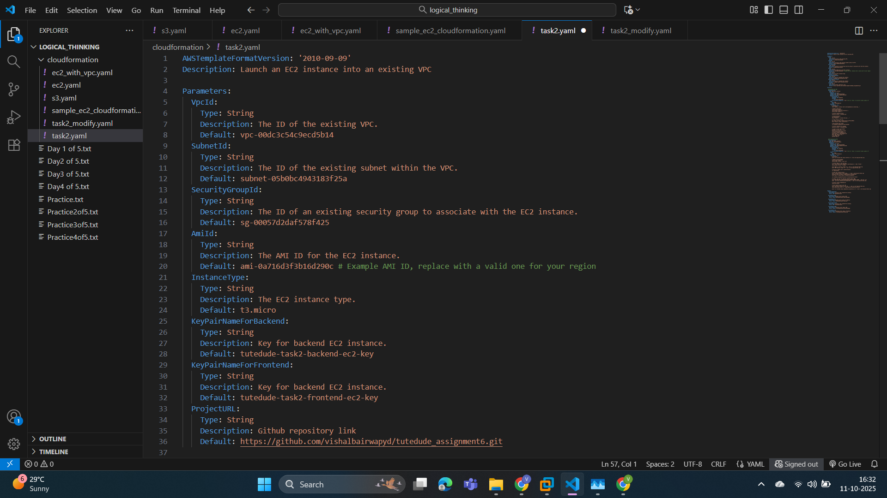

Now in this section we are creating our EC2 instance. First we are creating an EC2 resource for a Backend App(it serves APIs).

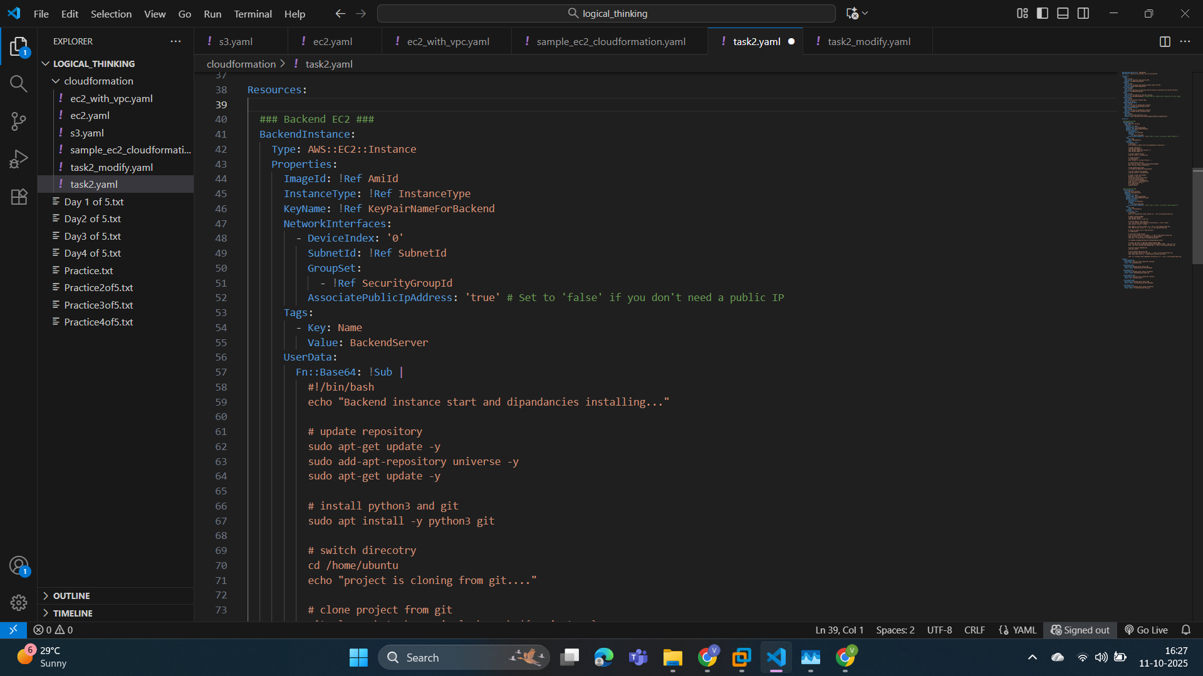

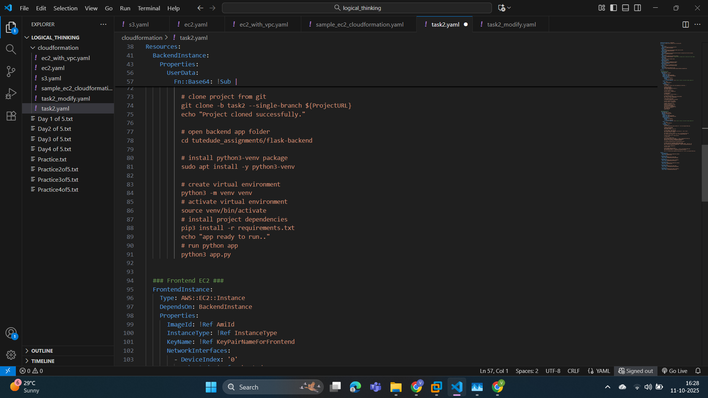

This is another EC2 instance for the frontend app(Express JS).

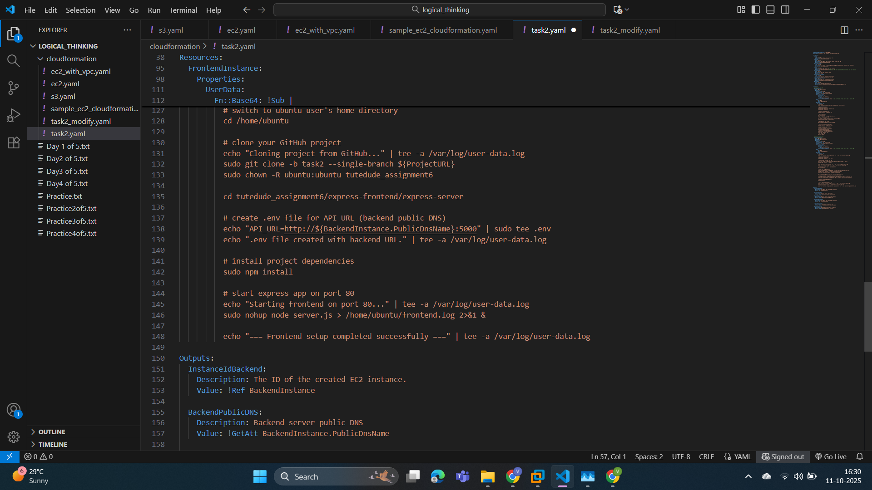

This is the last and import section that is “Output” here we are getting the **domain name**, **public IP** and **instance id** to access the both EC2 resources.

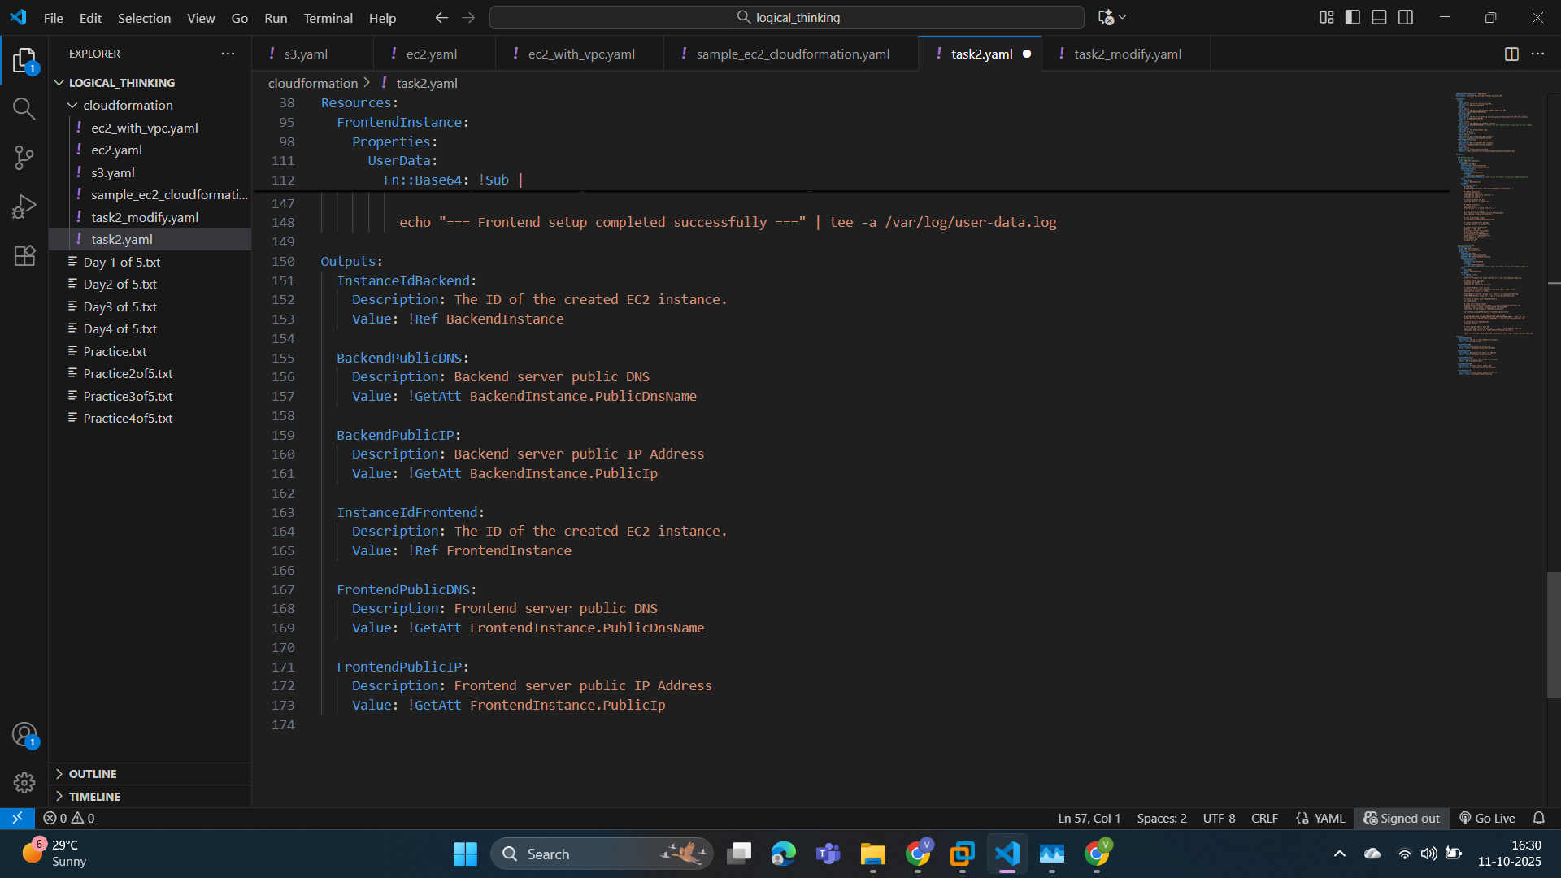

Step5: Now open **CloudFormation** service and create a stack by uploading a ".yaml” file or template.

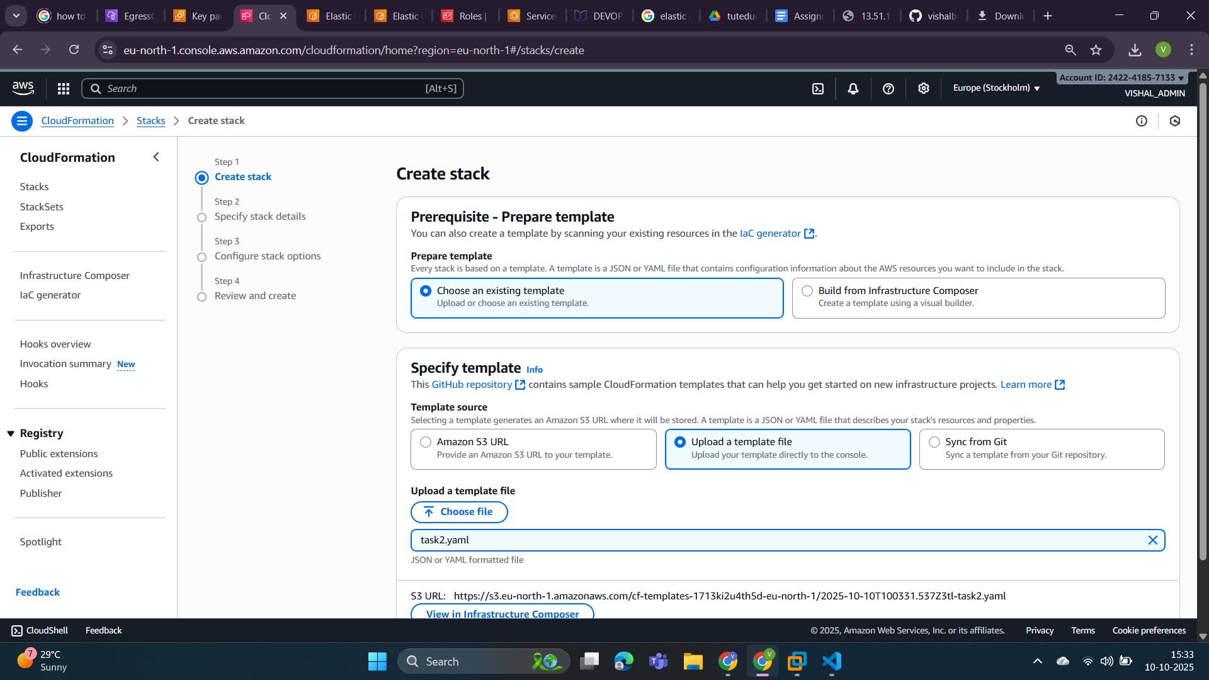

Infrastructure Composer view of our template (.ymal file).

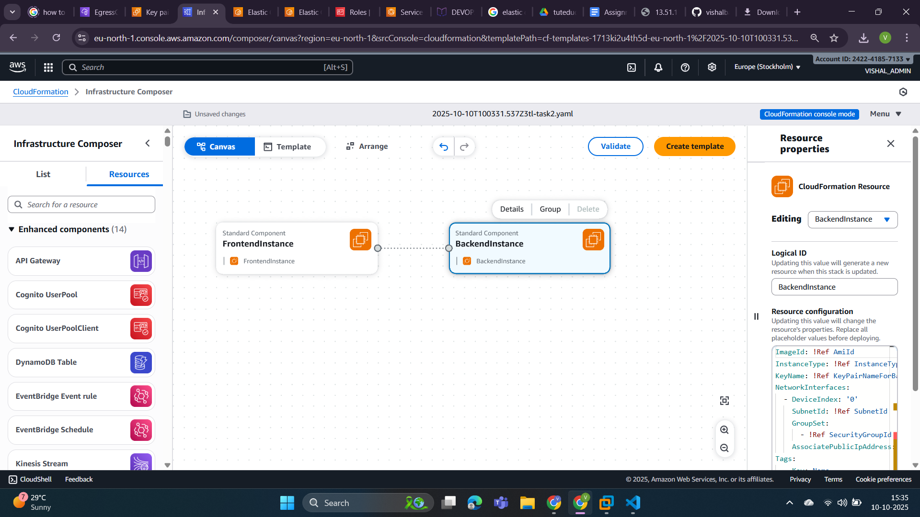

Now we put a stack name and you can see all the parameters.

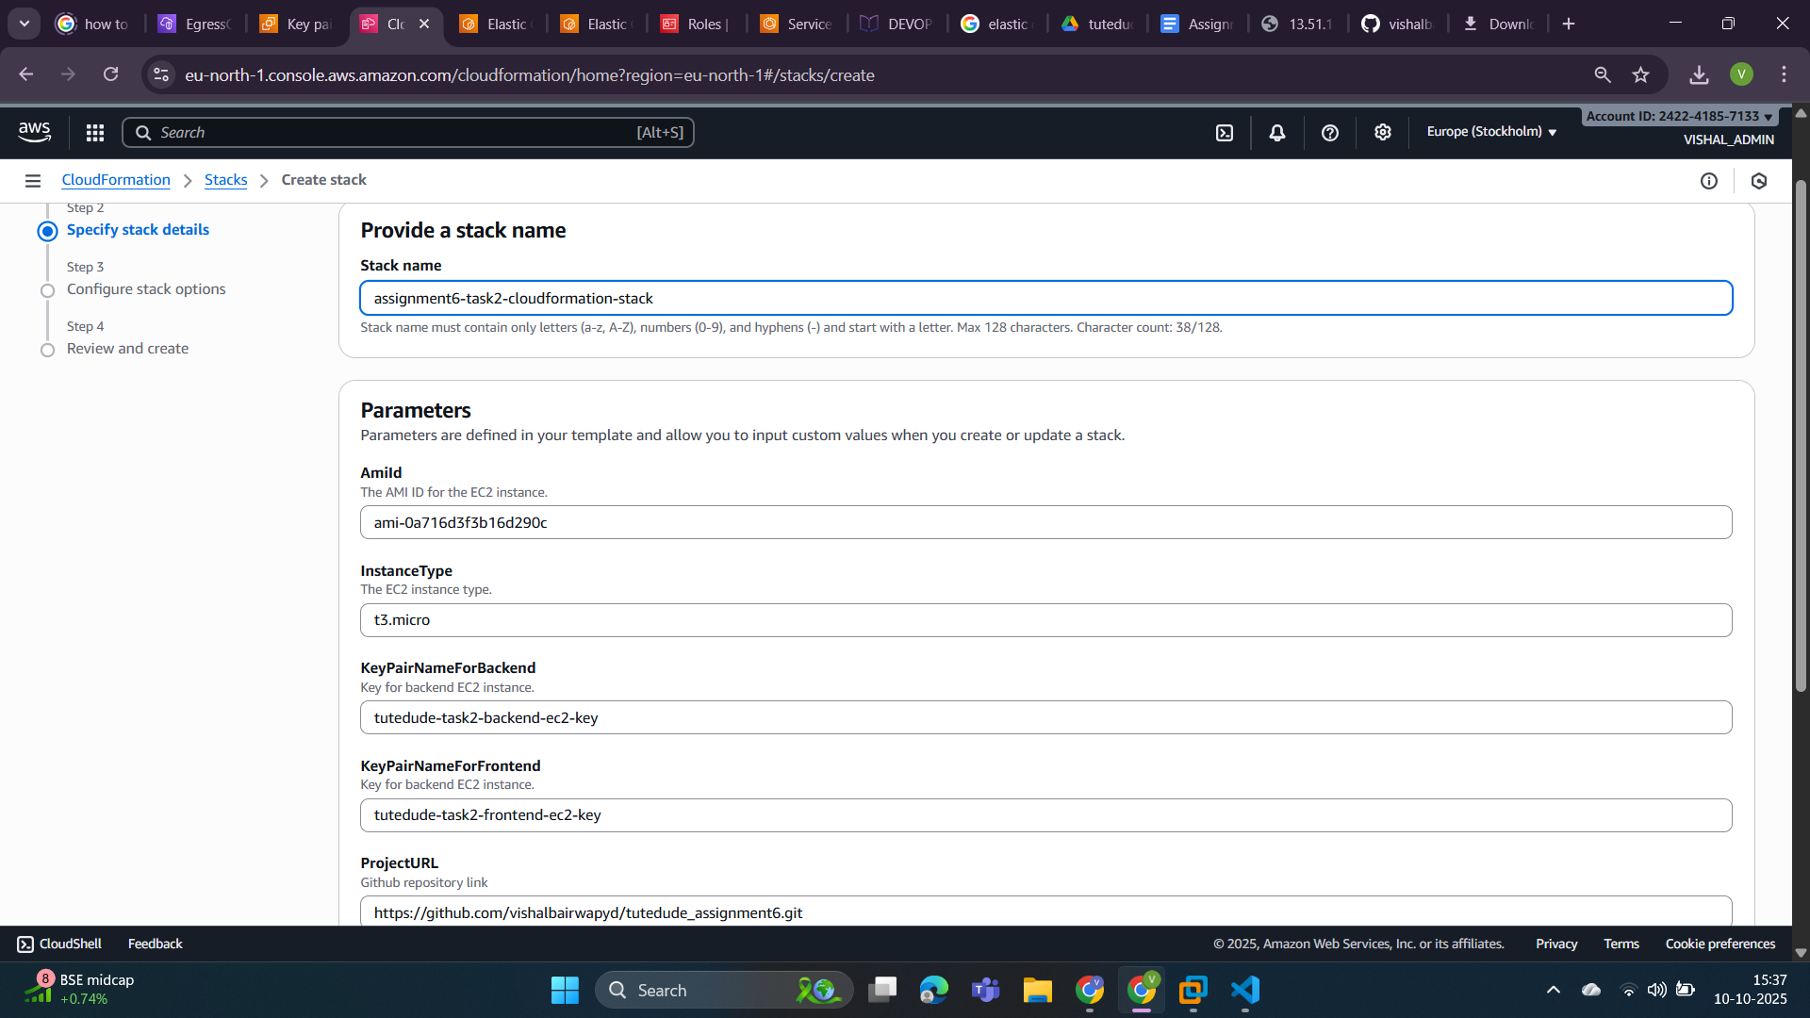

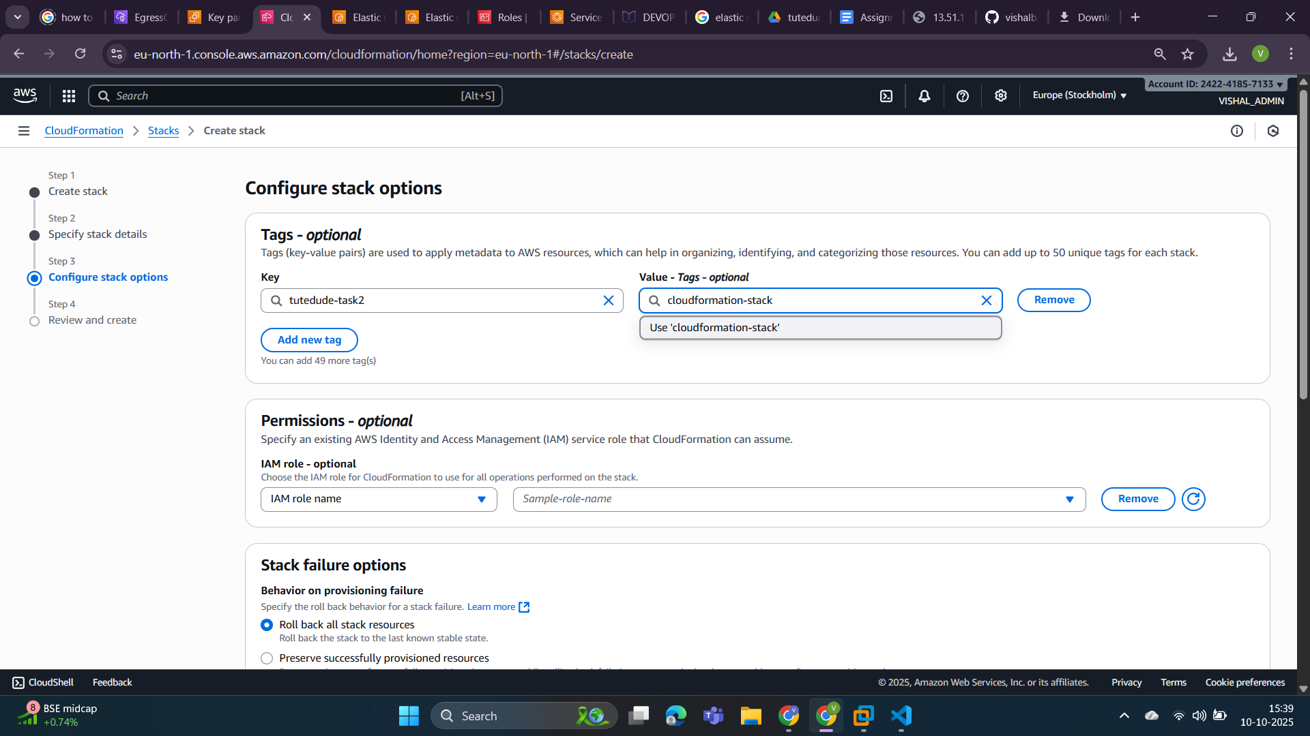

Now you can see template execution start.

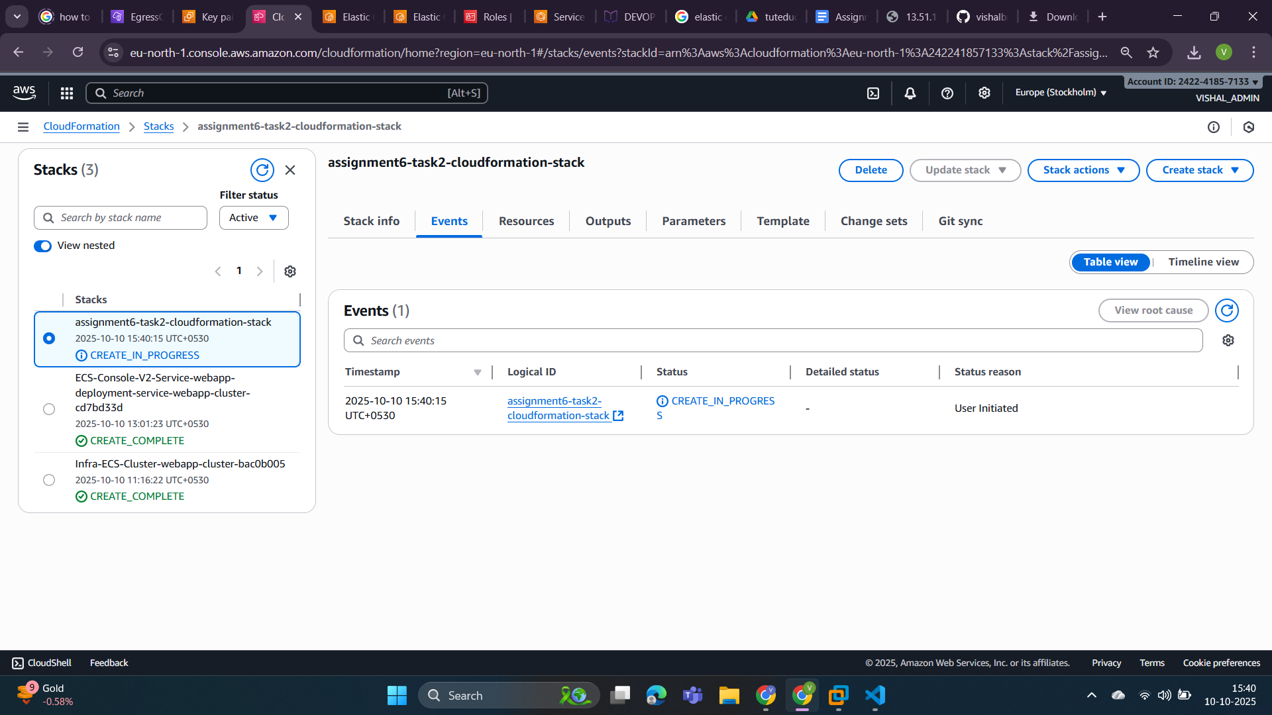

All the events have been successfully completed.

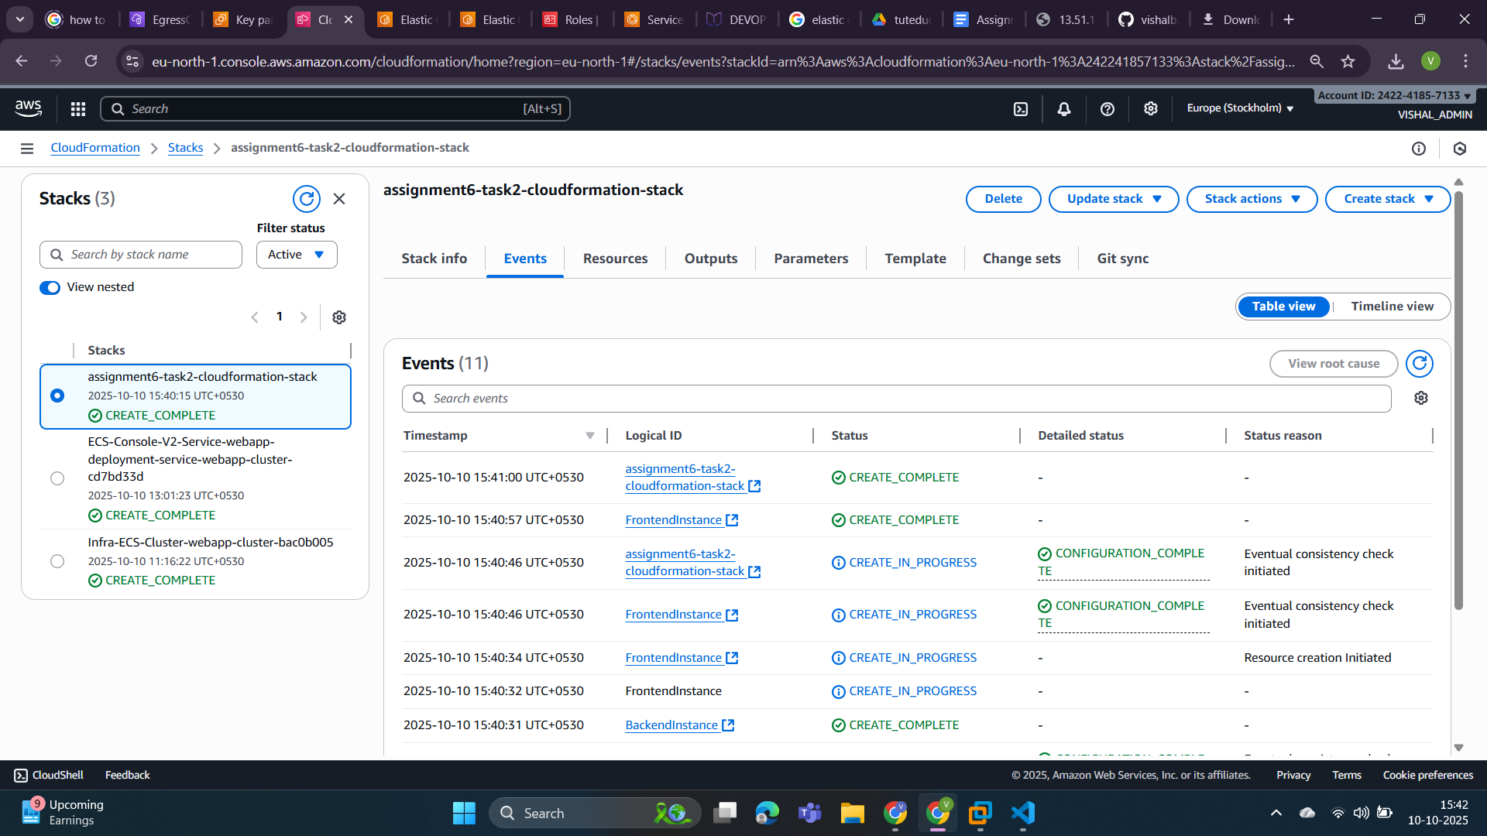

Now lets check the **output** table because we want Public IP or domain of both EC2 instances.

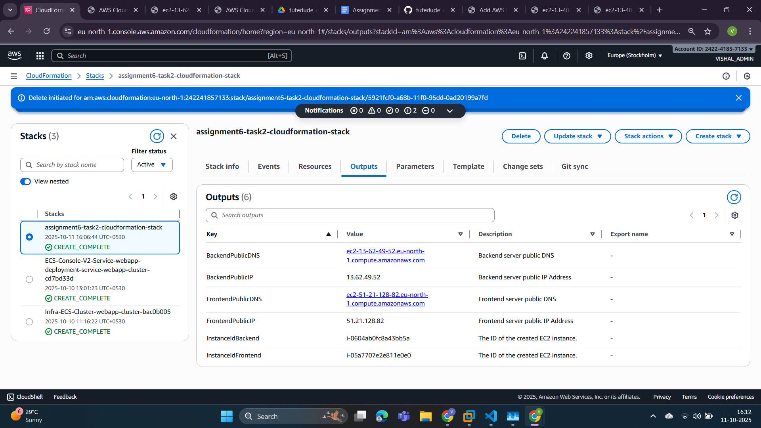

Step 5: Now in the above screenshot we have PublicDNS of both frontend and backend. Let’s check by searching them into the browser.

* Frontend url-> <http://ec2-51-21-128-82.eu-north-1.compute.amazonaws.com:3000/>

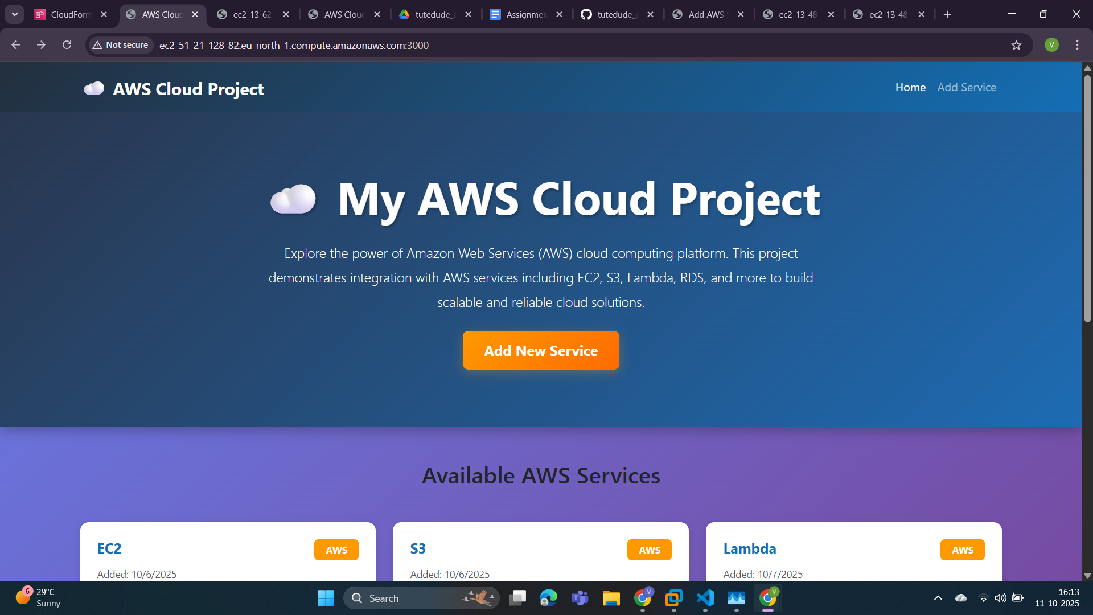

In the below screenshot we can see some services that is coming from mongodb database and it is added by a form that is popup when we click on the “Add New Service” button.

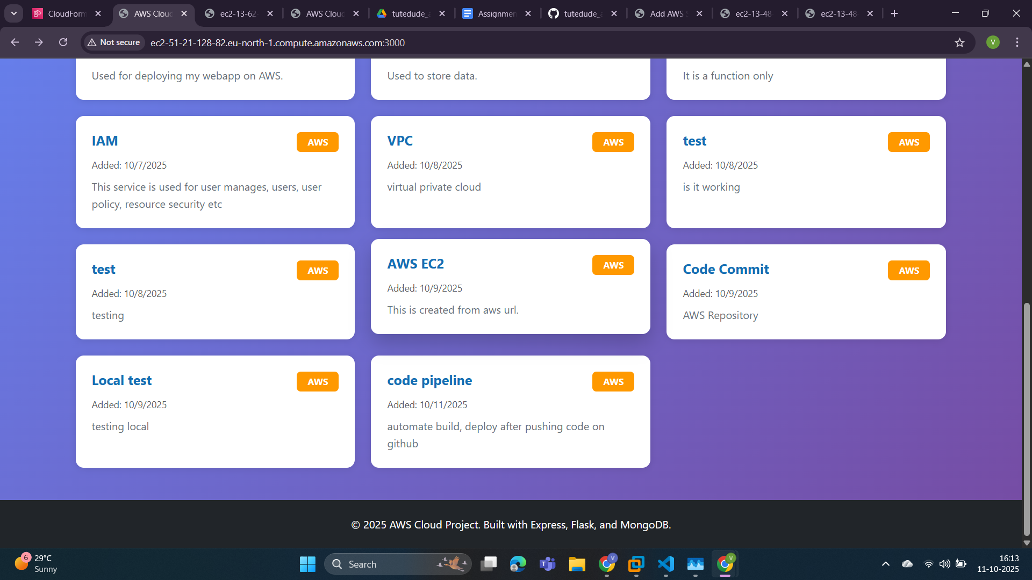

In the below screenshot we can see a form that is used to add services in our mongo db database using flask api.

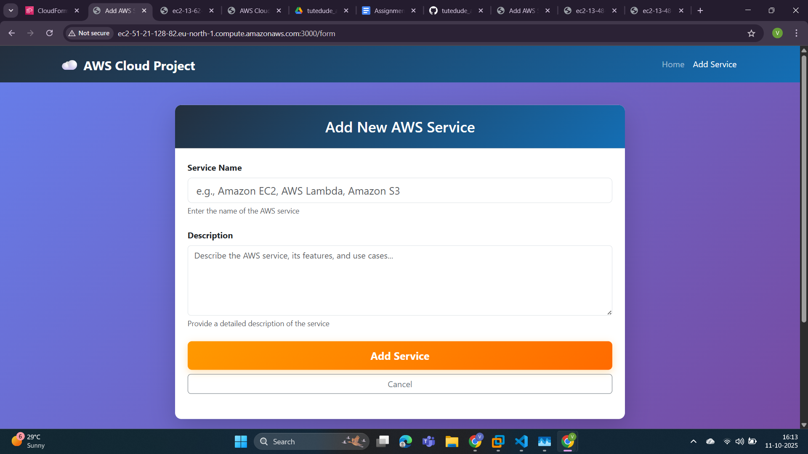

* Backend url ->

<http://ec2-13-62-49-52.eu-north-1.compute.amazonaws.com:5000/>

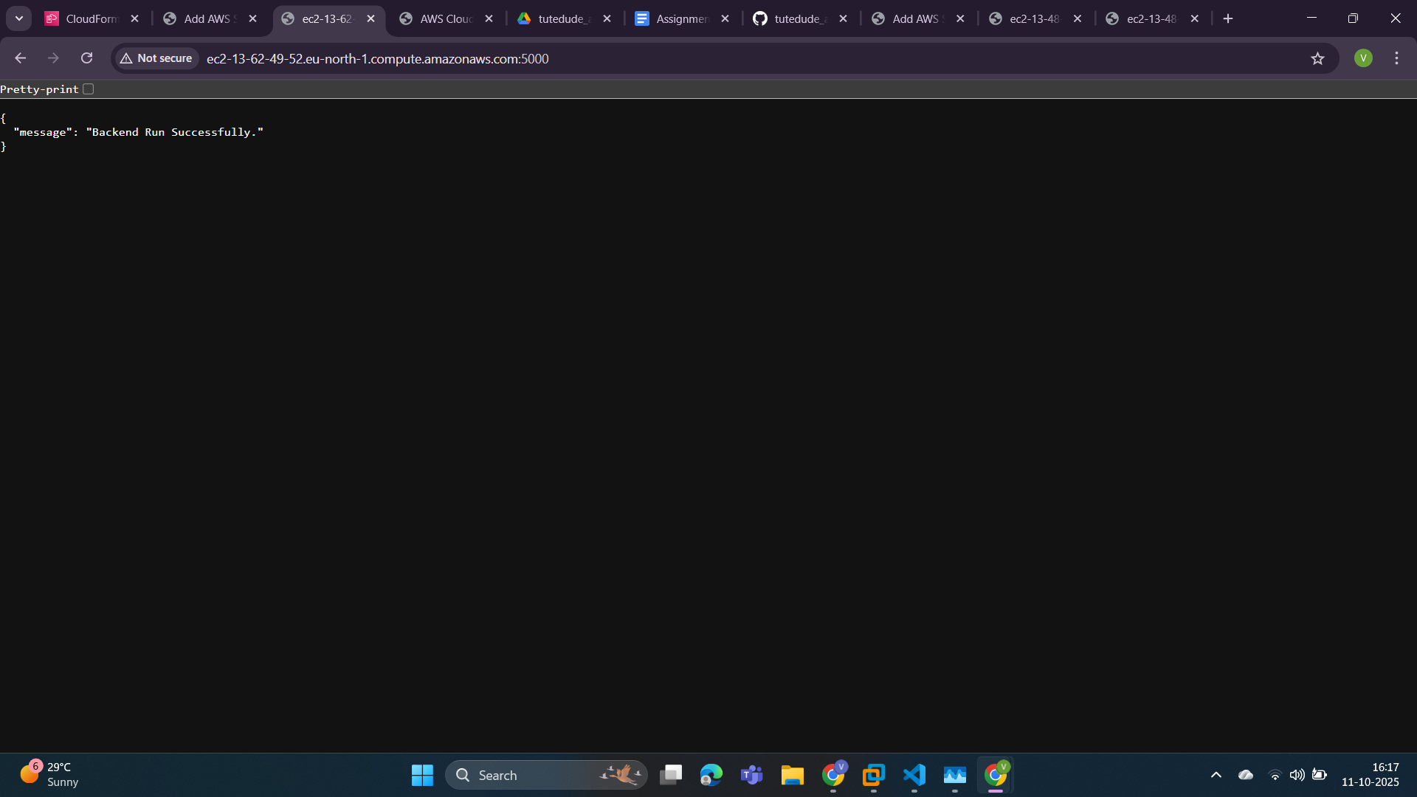

This end point “<http://ec2-13-62-49-52.eu-north-1.compute.amazonaws.com:5000/api/services>” is used to fetch all the services that have been added in the database.

